|  |  |  |
| --- | --- | --- |
| **Kingdom of Saudi Arabia Ministry of Education**  **Prince Sattam bin Abdul-Aziz University College of Science and Humanities - Al-Aflaj Department of Computer Science** |  | **المملكة العربية السعودية**  **وزارة التعليم**  **جامعة الأمير سطام بن عبدالعزيز كلية العلوم والدراسات الانسانية - الأفلاج**  **قسم علوم الحاسب** |

|  |
| --- |
| **Graduation Project – Part 1**  **"وجهتك علينا"**  **“Wajhatuk Ealayna Mobile Application”** |

|  |  |
| --- | --- |
| **No** | **Student Name** |
|  | Rawan Mahdi Alkabiriu |
|  | Raghad Mutlaq Aldawsarii |
|  | Noura Turki Al-Ajalin |

**Supervised by**

**Dr. Lobna Mueamar**

**———————————————————————————————**

**Semester one– 2024/ 2025**

|  |  |  |
| --- | --- | --- |
| **Kingdom of Saudi Arabia Ministry of Education**  **Prince Sattam bin Abdul-Aziz University College of Science and Humanities - Al-Aflaj Department of Computer Science** |  | **المملكة العربية السعودية**  **وزارة التعليم**  **جامعة الأمير سطام بن عبدالعزيز كلية العلوم والدراسات الانسانية - الأفلاج**  **قسم علوم الحاسب** |

|  |
| --- |
| **“Wajhatuk Ealayna Mobile Application”** |

**A Graduation Project Report Submitted to Sattam Bin Abdulaziz University for the Degree of Bachelor of Science in Computer Sciences**

|  |  |  |
| --- | --- | --- |
| **No** | **Student Name** | **Student Number** |
|  | Rawan Mahdi Alkabiriu | 442850245 |
|  | Raghad Mutlaq Aldawsarii | 443850250 |
|  | Noura Turki Al-Ajalin | 443850349 |

**Supervised by**

**Dr. Lobna Mueamar**

**———————————————————————————————**

**Semester two– 2024/ 2025**

**Abstract**

**"Wajhatuk Ealayna"** is a mobile application that aims to enhance the tourist experience in the Kingdom of Saudi Arabia and achieve integration and cooperation between visitors and the local community. This application constitutes a vital tributary to the Kingdom’s Vision 2030 as it enhances cultural interaction by encouraging tourists to participate in exchanging experiences with residents. In addition, it makes it easier for tourists to choose suitable accommodation and services near their favorite destinations, which is consistent with Vision 2030 to enhance the tourism sector and improve the visitor experience in the Kingdom of Saudi Arabia. It is an application that serves both tourists and Saudi citizens.

**الخلاصة**

**"وجهتك علينا"** هو عبارة عن تطبيق جوال، يهدف إلى تعزيز تجربة السائح في المملكة العربية السعودية وتحقيق التكامل والتعاون بين الزوار والمجتمع المحلي. يشكل هذا التطبيق رافداً حيوياً لرؤية المملكة 2030 حيث يُعزز التفاعل الثقافي من خلال تشجيع السياح على المشاركة في تبادل الخبرات مع السكان المحليين واكشاف الثقافة المحلية. بالإضافة إلى ذلك، يسهل على السائح اختيار سكن وخدمات ملائمة بالقرب من وجهاتهم المفضلة، مما يتناسب مع رؤية 2030 لتعزيز القطاع السياحي وتحسين تجربة الزوار في المملكة العربية السعودية. هو تطبيق يخدم كلا السائح والمواطن السعودي.

**Acknowledgement**

In the beginning, we thank Allah Almighty For The completion and for reaching this Stage and ending it as it should beautifully, We would like to express our sincere thanks and appreciation to Dr. Lubna Mueamar for her invaluable guidance, suggestions, and encouragement, as we did. We finished this project with her help, and we would like to thank all the group members for their cooperation, suggestions, and persistence until the end. Thanks to everyone.

في البداية نحمد الله تعالى على ما أتمناه، وعلى وصولنا إلى هذه المرحلة، واختتامها كما ينبغي، على أكمل وجه، ونود أن نعرب عن خالص شكرنا وتقديرنا للدكتورة لبنى معمر على توجيهاتها واقتراحاتها وتشجيعها الذي لا يقدر بثمن، كما فعلنا. أنهينا هذا المشروع بمساعدتها، ونود أن نشكر جميع أعضاء المجموعة على تعاونهم واقتراحاتهم واستمرارهم حتى النهاية، شكرًا للجميع.

# **Table of Contents**

**Introduction** ....................................................................................................... 6

**Chapter1**..............................................................................................................9

**1.1 Introduction .....................................................................................** **10**

**1.2 Problem Description .......................................................................** **10**

**1.3 The Proposed System ......................................................................** **12**

**1.4 Project Objectives ...........................................................................** **15**

**1.5 Project Scope ................................................................................... 1****6**

**1.6 Methodology ....................................................................................** **16**

**1.7 Project Plan .....................................................................................** **17**

**1.8 Conclusion ....................................................................................... 1****8**

**Chapter2** .......................................................................................................... 19

**2.1 Introduction ....................................................................................** **20**

**2.2 Related Works ................................................................................** **20**

**2.2.1 Program Ruh Al-Saudi ..............................................................** **20**

**2.2.2 Saudi Events .................................................................................** **22**

**2.2.3 Gathern .........................................................................................** **24**

**2.2.4 Saudi Tourism Tour .....................................................................** **25**

**2.2.5 Tripadvisor ...................................................................................** **27**

**2.2.6 Halabak ........................................................................................ 2****8**

**2.3 Similar Application Comparison ..................................................** **29**

**2.4 Conclusion .......................................................................................** **31**

**Chapter3** .......................................................................................................... 32

**3.1 Introduction .................................................................................... 3****3**

**3.2 Actors of System ............................................................................. 3****3**

**3.3 Functional and Non-Functional Requirements ........................... 3****4**

**3.3.1 Functional Requirements ............................................................ 3****4**

**3.3.2 Non-Functional Requirements ................................................... 3****7**

**3.4 Conclusion ....................................................................................... 3****7**

**Chapter4** .......................................................................................................... 38

**4.1 Introduction .................................................................................... 3****9**

**4.2 System Use Case ............................................................................. 3****9**

**4.3 Class Diagram ................................................................................ 4****5**

**Chapter5** .......................................................................................................... 47

**5.1 Introduction.................................................................................... 48**

**5.2TOOLS Selection: Database and programming………………….49**

**5.2.1 Database………………………………………………………..50**

**5.2.2 Programming Language……………………………………...51**

**5.3 FIREBASE REALTIME DATABASE: ............................................. 48**

**5.4 FLUTTER (DART): .......................................................................... 48**

**5.5 DATABASAE…………………………................................................ 48**

**5.6 User Interface Design ..................................................................... 48**

**5.6.1 Shared Interface ............................................................... 48**

**5.6.2 Admin Interface ............................................................... 48**

**5.6.3 Tourist Interface ................................................................. 48**

**5.6.4 Local Resident Interface .................................................. 48**

**5.7 Conclusion ...................................................................................... 48**

**Chapter6** .......................................................................................................... 47

**6****.1 Summary & Conclusion................................................................. 48**

**References .......................................................................................................** **49**

**List of Tables**

Table1: Project Plan……………………………………………………..…..…17

Table2: Comparison Of Applications…………………………………..…...…30

Table3: Actors and Roles…………………………...…………………..…...…33

Table4: …………………………...…………………..…...…33

**List of Figures**

Figure1: Waterfall Model..……………………………………………………..17

Figure2: Example of The Existing Similar Works (Program Ruh Al-Saudi) …20

Figure3: Program Ruh Al-Saudi .………………………………………...……21

Figure4: Example of The Existing Similar Works (Saudi Events) .……...……22

Figure5: Saudi Events .………………………………………………...…...….23

Figure6: Example of The Existing Similar Works(Gathern) .……………...….24

Figure7: Gathern………………………………………………...………...…...25

Figure8: Example of The Existing Similar Works(Saudi Tourism Tour) ……..25

Figure9: Saudi Tourism Tour ..…………………………………………….......26

Figure10: Example of The Existing Similar Works(Tripadvisor ) ..…………..27

Figure11: Tripadvisor …………...……...……...……...……...……...…..…....28

Figure12: Example of The Existing Similar Works(Halabak) ……………......29

Figure13: Halabak ………….……….……….……….……….………....…....30

Figure14: System Use Case Diagram Admin ………….……….…….....…....41

Figure15: System Use Case Diagram Tourist ………….……….…….....…....42

Figure16: System Use Case Diagram Local Resident ………….…….....…....43

Figure17: Class Diagram ……………………………………………………...46

Figure18: Database ……………………………………………………............46

**Introduction**

As technology develops at an ever-increasing speed, the world today has access to ways we could never have dreamed of. With these developments, the doors of modern technology open to countless opportunities to improve our experiences in various aspects of our lives, and achieve our goals in more efficient and effective ways than ever before.

In this context, the idea of ​​the “Wajhatuk Ealayna” application comes as an innovative initiative that combines the advantages of modern technology with the needs of tourists in the Kingdom of Saudi Arabia. Imagine a tourism application that puts the Kingdom of Saudi Arabia in your hands, giving you comprehensive information about tourist destinations, easy reservation services, and unforgettable interactive experiences. This is the “Wajhatuk Ealayna” application, an integrated platform to make your trip to the Kingdom exceptional.

Our application has everything you are looking for for an unforgettable trip to the Kingdom of Saudi Arabia. You can easily find comprehensive information about tourist destinations, events, restaurants, cafes, entertainment venues, and everything you desire. The application also provides various reservation services that include hotels, apartments, and housing experiences. With local residents and means of transportation, it makes it easier for tourists to plan, schedule, and organize their trips in an easy and organized manner.

Let us also not forget the benefits that the application brings to local residents. They can rent their homes to tourists and offer their local products and dishes for sale through the application, which allows them to market foods and provide unique tasting experiences for tourists, thus obtaining additional income, which strengthens the local economy and exposes their culture to the world directly.

Our project reflects the Kingdom of Saudi Arabia’s commitment to developing the tourism sector and enhancing its position as a leading global tourist destination. By employing the latest technologies and meeting the growing needs of tourists, we contribute to achieving the goals of the Kingdom’s Vision 2030 in this field. With the increasing pace of technological development, it has become necessary to keep up with the changes. In tourists’ behaviors and needs, tourists today are looking for interactive and integrated tourism experiences that allow them to explore the destination easily and conveniently, Therefore, our application comes to play a pivotal role in meeting these needs, by providing advanced services that enrich the tourists’ experience and enhance their satisfaction.

The report will consist of four different chapters, with each chapter focusing on a specific aspect of the project. In the first chapter, we will address the general context of the project, defining the background and purpose of creating the application and its importance in tourism in the Kingdom. As for the second chapter, it will aim to review and compare related works. To better understand the market and the available opportunities, in the third chapter, we will analyze the system requirements in detail, including the features and functions required to achieve the project goals. The last chapter will be devoted to presenting the system design, where we will draw use case diagrams and categories to illustrate how the application works and how users interact With it.

**Chapter 1**

**General Context Of The**

**Project**

**1.1 Introduction**

Through this chapter, we will discuss the problem that made us choose this project.

We will present also a description of the proposed system, its objectives, and its scope. Finally, we will define the methodology and the plan followed during this project.

**1.2 Problem Description**

Vision 2030 in the Kingdom of Saudi Arabia aims to achieve comprehensive changes starting from various days, including the tourism sector, which can be one of the main components of economic growth. Despite the great progress that has been achieved in this field, there are some challenges and problems that the tourism sector in the Kingdom of Saudi Arabia faces despite the availability of great tourism potential, as many of the problems and difficulties facing tourists in the Kingdom of Saudi Arabia and the population are not noticed, and this explains why they benefit from the country sufficiently and have few choices, as this is evident in the weak performance in Attracting tourists compared to other countries.

One of the main problems relates to improving cultural awareness and promoting heritage and tourist attractions, as there may not be sufficient awareness about Saudi culture and history among international tourists, and this can lead to a reduction in the attractiveness of tourist destinations.

Problems also include a lack of development of tourism marketing infrastructure and enhanced promotion of tourist destinations, as well as promotion of tourism infrastructure, such as transportation and accommodation, to ensure a comfortable tourist experience.

The problems that tourists suffer from in the Kingdom of Saudi Arabia are the high costs of hotel accommodation and their exposure to some obstacles such as fraud regarding, for example, the quality and location of the place they choose to stay. Another problem that tourists face is the difficulty of dealing with the local language and understanding the local culture, which may affect their tourism experience negatively, the tourist is also exposed to the possibility of being referred to by vehicle drivers at the airport, and he also needs a tour guide to help him navigate the tourist sites in the Kingdom due to his lack of experience in knowing the areas that he can visit, and it can also be pointed out the problem of lack of effective interaction. Between tourists and local residents in the Kingdom of Saudi Arabia, which negatively affects the tourists’ experience and limits local residents’ benefit from the available economic opportunities.

Despite the increase in the number of tourists, we note that the local population who can help visitors to the Kingdom are not benefiting greatly, as well as the lack of encouraging job opportunities for the local population and their lack of skills that enable them to benefit from tourism growth, and this requires developing balanced solutions that ensure that the local community and tourists benefit from Both, and an encouraging environment must be provided for small and medium enterprises that can serve tourists and the local community together.

We can summarize the most important problems facing the tourism sector in the Kingdom as follows:

1. **Lack of cultural communication:** Tourists lack effective cultural interaction with local people, which reduces the value of their tourism experience.
2. **The local citizen does not benefit from the available opportunities:** Local residents lack opportunities to rent their homes and provide their services, which limits the opportunity to develop and improve their financial income.
3. **Loss of economic opportunities:** Owners of small and local community projects do not benefit from sufficient interaction from tourists due to lack of care and support, which leads to loss of local economic opportunities.
4. **Lack of promotion of local heritage and culture:** Local cultural experiences lack adequate promotion, which reduces the tourist attraction of local heritage.
5. **Negative impact on community spirit:** The lack of interaction leads to a loss of local community spirit and positive interaction between local residents and visitors, as there are no strategies to enhance cultural interaction and encourage tourists to actively participate with the local community, which stimulates the local economy and enhances awareness about the importance of communication between tourists and local residents.
6. **Poor infrastructure:** Some tourist areas may lack adequate infrastructure such as transport and communication, which affects and reduces the attractiveness of those areas for tourists.
7. **Lack of training and qualification:** There may be a lack of training and qualification opportunities in the field of tourism, which makes local residents lack the necessary skills to provide distinguished services to tourists.
8. **Lack of tourism awareness:** Some local residents may suffer from a lack of awareness of the importance of the tourism sector and how to best benefit from it, which can affect the extent of their willingness to work in this sector.

**1.3 The Proposed System**

**“Wajhatuk Ealayna”** is a mobile application that aims to achieve integration between visitors and the local community. This is done by encouraging tourists to participate in exchanging experiences with local residents and discovering local culture. In addition, it makes it easier for tourists to access various available services, such as choosing suitable accommodations near their favorite destinations, learning about various events in the cities where the tourist resides, and some recommendations for using the most important access applications for different needs such as (market, pharmacy, medical clinic). Local residents in the Kingdom can also benefit from our application by renting their house or a room from their house for a specific period to visitors to the Kingdom or providing them with some other services. **List of features:**

1. **A comprehensive tourist guide and introduction to the Kingdom:** Provides information about tourist places, events, and local services.
2. **Local experiences:** Local residents can provide unique experiences for tourists, such as tourist trips and trying popular food served by productive families.
3. **Protection from fraud:** Adding “The event link documented by the Ministry of Tourism”.
4. **Review of local products.**
5. **Ratings and Recommendations.**
6. **Tips and Advice.**
7. **Financial benefit for local residents.**
8. **Getting to know the local heritage and culture:** through presenting tourists’ experiences, local cultural images, popular sessions, and popular foods.
9. **Identifying archaeological sites.**

**Services provided by the application to Tourists:**

1. **A review of the services provided by the application:** tourist places, a review of events and celebration seasons, and local services such as housing or housing sharing, restaurants and cafes, delivery applications, and bus stopping places, services such as (market, pharmacy, medical clinic, hospital), where the tourist chooses the area and duration. In which he will stay, he will be presented with several options for the activities held during his stay, the type of house he wants to choose (a room, an apartment, a villa, or shared housing), and the services that are supposed to be close to the residence (restaurants, cafes, market, pharmacy, medical clinic). (Hospital) shows him a set of options. He chooses the appropriate accommodation for him, where he can review pictures of the house before booking it, read the description of the services available in this house, and read the comments of other tourists who have previously booked in this house.
2. **Getting to know the archaeological sites:** The tourist can choose a specific area and be shown the archaeological and religious sites of this area and how much they worship his place of residence.
3. **Tips and advice:** The application provides tips and advice for tourists, tips, and advice so as not to be scammed and defrauded.
4. **Ratings and recommendations:** Tourists can evaluate services and experiences and leave recommendations for other tourists, as tourists can evaluate the place of residence and the house in which they reside.
5. **Getting to know local products and popular foods:** by knowing the places that sell these products and where they are located by seeing pictures of traditional and artistic handmade products through the application.
6. **Protection from fraud:** by providing tourists with an “event link documented by the Ministry of Tourism” to purchase or reserve a ticket for events and celebration seasons.
7. **Reviewing the tourist trips held in this region and tourist activities.**

**Services provided by the application to local residents:**

1. **Local residents rent their homes and benefit financially:** through local residents renting their homes (room, apartment, villa, or shared housing) or popular tents or chalets to tourists by adding pictures and descriptions of the home and the services near it (restaurants, cafes). , market, pharmacy, medical clinic, hospital), the period during which the house is available, the location of the house, adding a location map, services available in the house (air conditioning, number of bathrooms, which floor, presence of a parking garage).
2. **Adding local products:** Urging the local community to participate by providing their services and products, where the local community can display their traditional handmade and artistic products through the application.
3. **Reviewing tourists' reviews and recommendations for the homeowner** who offered it for rent by trying to improve the services he provides and encouraging him to continue.

**1.4 Project Objectives**

This project is a mobile application that serves, on the one hand, tourists coming to the Kingdom, and on the other hand, local residents, as it provides easy and quick access to various available services. The main **objectives are summarized as follows:**

* Enhance interaction by adding tourists, evaluating the place of residence, the house in which they lived, comments on the services provided, and leaving recommendations for other tourists. Reviewing tourists’ evaluations and recommendations for the house owner that he offered for rent by trying to improve the services he provides and encouraging him to continue.
* Suggesting suitable accommodation for you within your budget and close to the destination.
* Improving local income for citizens: Increasing opportunities to rent houses and apartments to tourists to increase the income of local residents.
* Providing an electronic guide: Creating an electronic tourist guide that provides accurate and effective information about tourist places, restaurants, and activities, to be a reliable companion for tourists during their trip.
* Providing various entertainment options: Providing information about entertainment places and local events, contributes to diversifying entertainment options for tourists.
* Support cultural diversity: Promote understanding between tourists and locals by encouraging sharing accommodation with locals and cultural exchange.
* Securing tourist funds and protecting them from theft and fraud by providing reliable delivery programs that enhance trust between customers and the services provided, adding official websites for the official events held, and directing the user directly to the site with one click.
* Easily add local residents to their homes.
* Ease of knowing the events and activities that take place during the tourist’s stay.
* Easy to learn about local culture and popular foods.
* Introducing tourists to tourist and heritage places in the Kingdom.

**1.5 Project Scope**

The application supports tourists and visitors who visit the Kingdom and want to discover the various cities of the Kingdom and the landmarks available therein. Local residents in the Kingdom also benefit from it, as they can offer their various services on the application, Our application provides everything the visitor needs in terms of various services, such as displaying restaurants, cafes, hotels, malls, and entertainment seasons, It also helps the user in the process of booking, searching, viewing reviews of tourist destinations, and displaying effective delivery applications in the regions.

**1.6 Methodology**

In this project, we are going to follow the Waterfall model. In "The Waterfall" approach, the whole process of software development is divided into separate phases.

In this model, typically, the outcome of one phase acts as the input for the next phase sequentially.

All these phases are cascaded to each other in which progress is seen as flowing steadily downwards (like a waterfall) through the phases, The next phase is started only after the defined set of goals are achieved for the previous phase and it is signed off, so the name "Waterfall Model", In this model, phases do not overlap.[1]

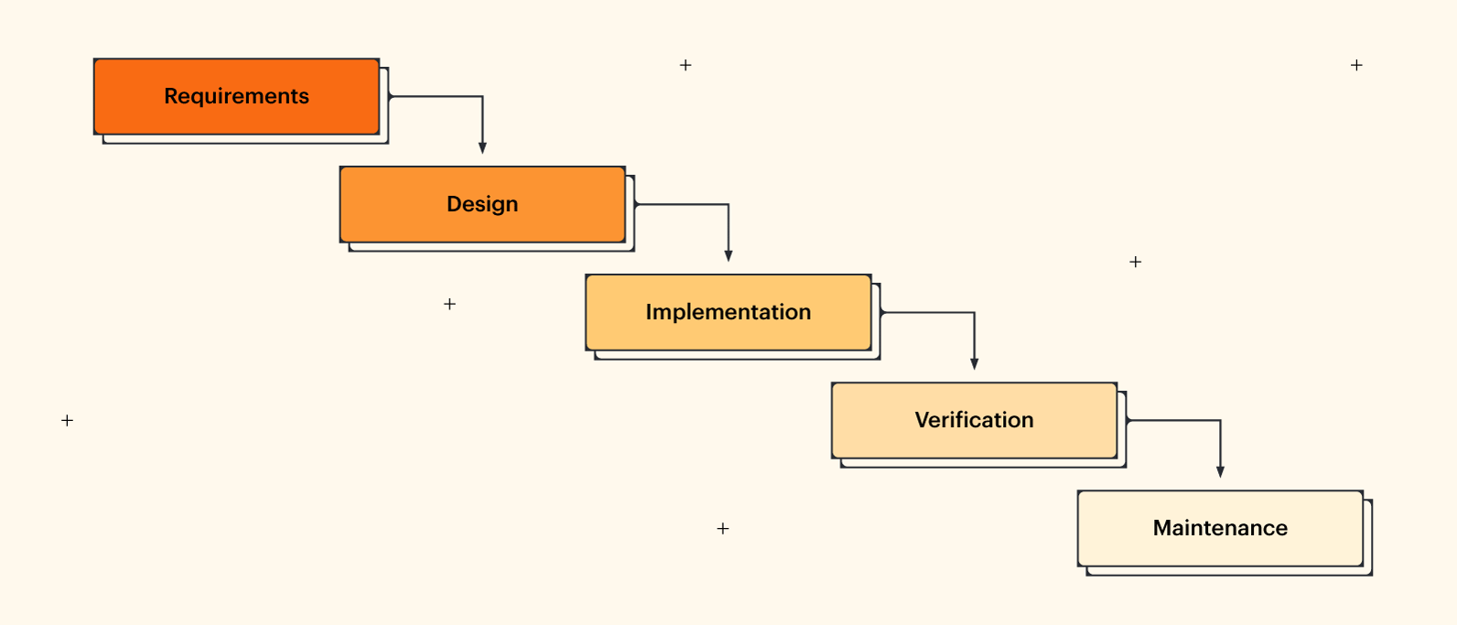

Figure 1 (Waterfall Model)

**1.7 Project Plan**

The figure below is the project plan for our project, Google Sheets is a spreadsheet application included as part of the free, web-based Google Docs Editors suite offered by Google. Google Sheets is available as a web application; a mobile app for Android, and IOS, and as a desktop application on Google's ChromeOS. The app is compatible with Microsoft Excel file formats [2].

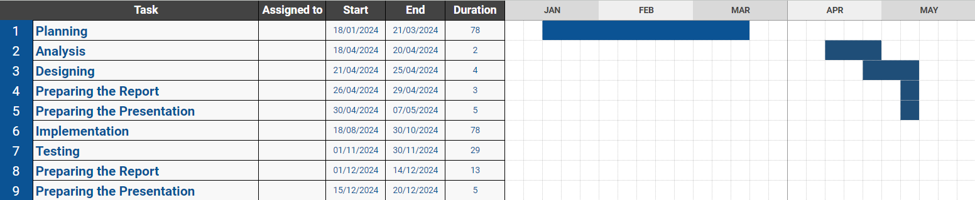

Table1 Project Plan (Google Sheet)[3]

**1.8 Conclusion**

We talked about the “**Wajhatuk Ealayna**” application, which promotes integration between tourists and the local community, providing a description of the project’s problem, the proposed system, and its objectives. We have explained the system, methodology, and plan adopted during the project. In the next chapter, we will review and compare some applications similar to ours.

**Chapter 2**

**Literature Review**

**2.1 Introduction**

The purpose of this chapter is to present a review of some similar applications, mentioning some advantages and disadvantages of each one.

Finally, we will present a comparison between these applications.

**2.1 Related Works**

During this stage, we will present some applications similar to our application and make a comparison to take advantage of the advantages and avoid the defects of these applications.

**2.2.1 Program Ruh Al-Saudi**

“**Program Ruh Al-Saudi**” is an official application from the Saudi Tourism Authority, which provides comprehensive information about activities, events, and tourist places in the Kingdom of Saudi Arabia. It is considered a comprehensive tourist guide that includes tourist sites, restaurants, and markets, in addition to beaches and public parks. The app highlights the amazing culture and influences of the Kingdom, showcasing the enchanting nature, cultural heritage, and natural beauty of the Kingdom. It allows users to view an interactive map and events calendar to facilitate the travel and exploration experience [4].



Figure 2 (Example of The Existing Similar Works)

**Advantages:**

* **Interactive map:** easily shows events and attractions.
* **An updated tourist guide:** includes restaurants, hotels, and various places.
* **Different climates and seasons:** Information about the weather and seasons in the Kingdom.

**Disadvantages:**

* **Availability in Arabic:** The app may be limited in Arabic, which can be a challenge for non-Arabic speaking users.
* **Presentation of information:** Some information may be unclear or insufficient, requiring improvement in the quality and completeness of the content.
* **Availability of Features:** Some users may experience unavailability of certain features or data in some areas, affecting their full benefit from the application.

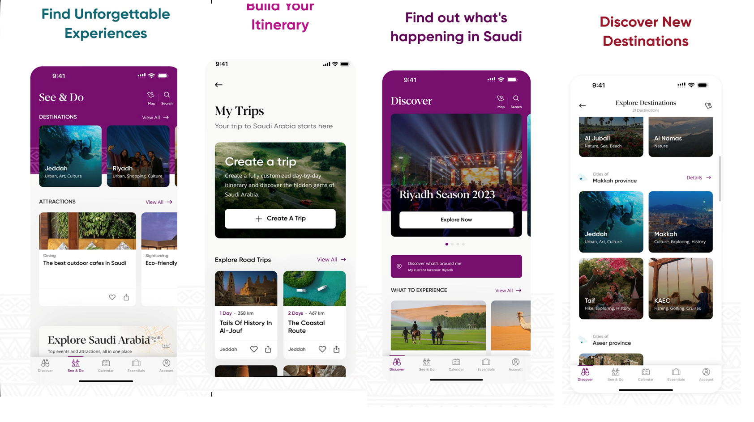

Figure 3 ( Program Ruh Al-Saudi)

**2.2.2 Saudi Events**

The **Saudi Events** application is an interactive platform that provides users with a rich experience of various events and entertainment activities, which are held throughout the Kingdom of Saudi Arabia, It reviews the events and publishes the most important details to users, for example, geographical location, time, date, description of the event, and a box to purchase a ticket. There is a section for the main areas in the events, and it will have a description, address, and a map displaying the facilities and services. There will be a photo album and videos available for the large areas. There is also a feature to filter events according to interests and regions to facilitate access to the required events [5].



Figure 4 ( Example of The Existing Similar Works)

**Advantages:**

* **Easy navigation between events:** The application makes it easy for users to browse all events and activities, and search for them by category, date, or location.
* **Easily purchase tickets:** The application allows users to purchase tickets for various events easily and quickly, without having to wait in long lines.
* **Know all the details:** The application provides comprehensive information about each event, such as date, location, description, and prices, in addition to photos and videos.

**Disadvantages:**

* **Not linking to Google Maps:** difficulty locating the event on the map, inability to use the navigation feature to reach the event, inability to know the time distance to reach the event.
* **Not being alerted about nearby events:** not being able to know what events are being held in the area surrounding the user, missing the opportunity to attend some events that may be of interest to the user.
* **Some events are not available in Arabic:** Some events and activities may not be available in Arabic, which may prevent some users from benefiting from them.

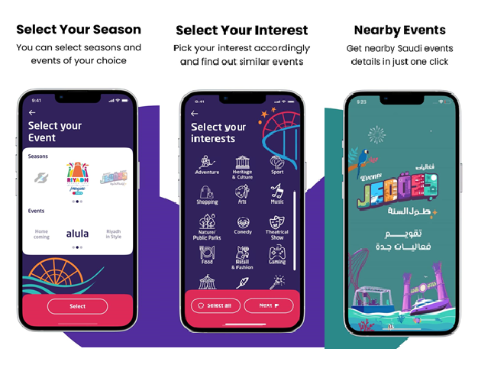

Figure 5 ( Saudi Events)

**2.2.3 Gathern**

**Gathern** is a platform licensed by the Ministry of Tourism. The Gathern platform offers the traveler an experience different from the traditional travel experience through a receipt for accommodations provided by the people of the regions so that he can discover the region closely, and supports the people of these regions to exploit their properties, receive guests, and obtain an excellent additional monthly income.

The Gathern platform currently covers more than 185 cities and governorates around the Kingdom, and has various options of chalets, rest houses, resorts, camps, farms and apartments, that suit all tastes, as the platform enables users to easily search through thousands of options, and book via Internet, and secure payment methods [6].



Figure 6 ( Example of The Existing Similar Works)

**Advantages:**

* Increasing the supply and diversity of tourist accommodation facilities offered in the Kingdom of Saudi Arabia.
* Book your home instantly and your reservation is 100% guaranteed.
* Secure payment methods Multiple and secure payment methods.

**Disadvantages:**

* **User Experience May Vary:** Due to the changing nature of homes and residences, user experience may vary significantly from one residence to another.
* **Some listings may have issues:** Problems or issues may occur with some listings, which requires effective management to meet users' expectations.
* **Communication issues:** Communication issues can arise between tenants and landlords, such as delayed responses or disagreement over reservation details.

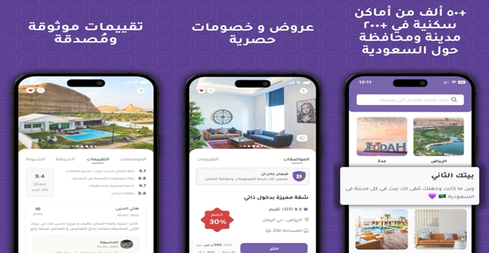

Figure 7 ( Gathern)

**2.2.4 Saudi Tourism Tour**

The **Saudi tourism tour** application, which takes you on a simplified, brief and enjoyable introductory tour to the most beautiful and best landmarks and tourist destinations in the Kingdom of Saudi Arabia, which includes 13 administrative regions, namely (Riyadh ~ Makkah Al-Mukarramah ~ Medina ~ Al-Sharqiyah ~ Asir ~ Al-Qassim ~ Tabuk ~ Jazan ~ Hail ~ Al-Baha ~ Al-Jawf ~ Najran ~ Northern Borders) and each of these regions has its own tourist flavor that is distinct from others [7].



Figure 8 ( Example of The Existing Similar Works)

**Advantages:**

* Support for Android and iOS platforms.
* Protected with an encryption certificate to maintain security.
* Support for multiple languages to expand the user base.

**Disadvantages:**

* The information needs to be updated periodically.
* You may encounter some technical problems from time to time.
* Interaction with mentors may be inconsistent.

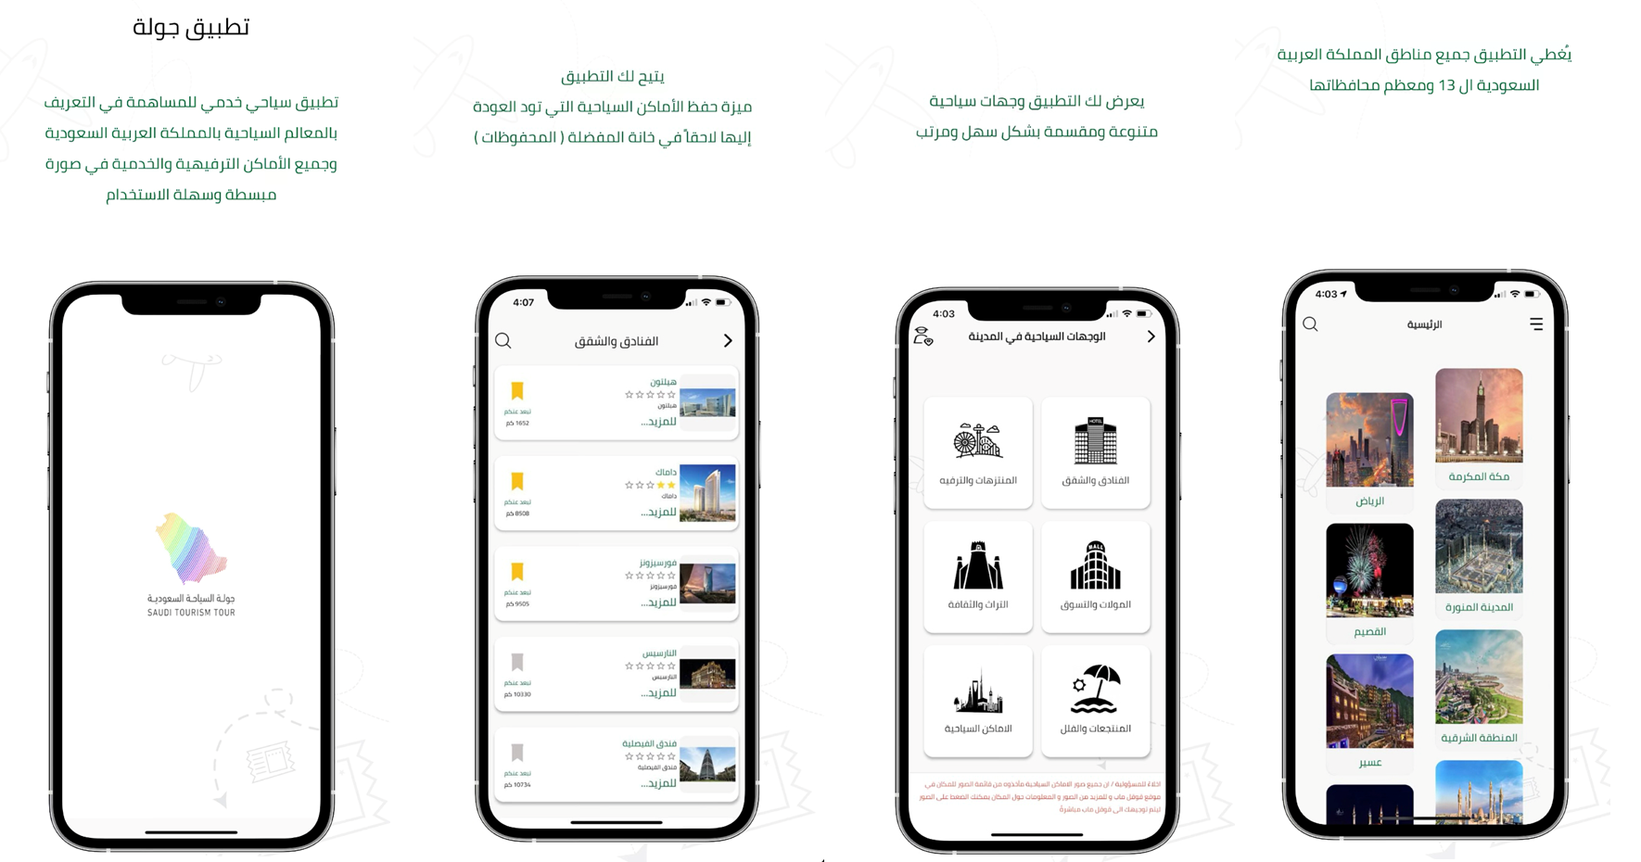

Figure 9 ( Saudi tourism tour)

**2.2.5 Tripadvisor**

It is a company that specializes in providing advice and guidance related to trips and travel, **Tripadvisor** brings together people, diverse passions, and different places, The application aims to help you have a better travel experience, starting from planning travel, through booking, and ending with enjoying a special trip. The application allows you to make the most of your trip Whether you're planning a trip or traveling, discover places to stay, things to do, and places to eat based on tips from millions of travelers who have been to your destination before.

Get travel tips and access millions of reviews of hotels, restaurants, tours, attractions, and other experiences from travelers just like you [8].



Figure 10 ( Example of The Existing Similar Works)

**Advantages:**

* **Real Reviews and Opinions:** You can read real travelers' experiences and opinions about hotels, restaurants, and different experiences.
* **Categories and Filtering:** You can filter results by location, rating, price, and more to find the perfect options for you.
* **Location Map:** Provides you with a map showing the locations of hotels, restaurants, and tourist attractions to facilitate planning and navigation.

**Disadvantages:**

* **Technical compatibility issues:** You may encounter some technical problems with the compatibility of the application on different operating systems or devices.
* **Differences in quality:** There may be a difference in the quality of the information or images provided by the application, which may affect the user experience.
* **Poor interaction:** Interaction with users may be insufficient or slow at times, affecting your ability to get help or inquiries quickly.

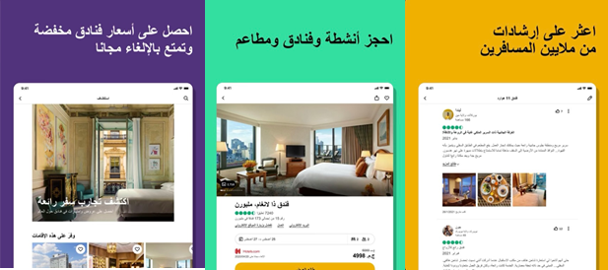

Figure 11 (Tripadvisor)

**2.2.6 Halabak**

The **Hallabak** application (a unique journey portal in the world of tourism) The Hallabik application is an interactive platform that provides users with a distinctive tourism experience by facilitating the process of searching for various tourism events, activities, and offers in the Kingdom of Saudi Arabia [9].



Figure 12 ( Example of The Existing Similar Works)

**Advantages:**

* The ability to share your trip with family and friends: The application allows users to share their trip plans with family and friends, making it easier for them to coordinate and meet during the trip.
* Possibility of booking flights and accommodation hotels: The application allows users to book flights and accommodation hotels easily and quickly through the application.
* Possibility of obtaining tourist advice and guidance: The application provides users with useful tourist advice and guidance, such as information about the best places to visit and the best activities that can be done in each region.

**Disadvantages:**

* **Lack of events and activities:** The number of events and activities available on the application may be limited. Not all events and activities that take place in the Kingdom of Saudi Arabia may be available on the application.
* **Some events are not available in Arabic:** Some events and activities may not be available in Arabic, which may prevent some users from benefiting from them.
* **Lack of interaction:** There may not be enough interaction between users on the application, and users cannot share experiences with each other.

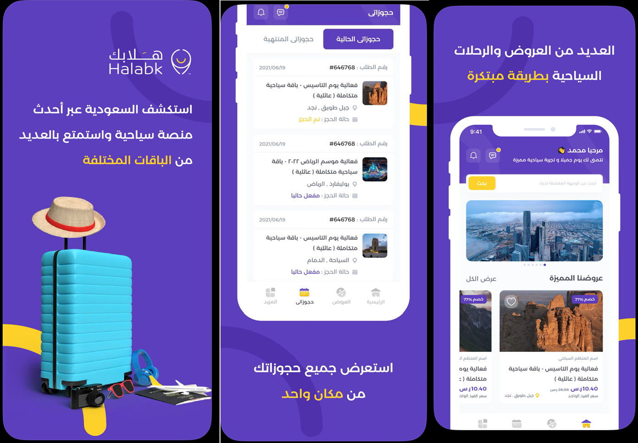

Figure 13 (Halabak)

**2.3 Similar Application Comparison**

|  |  |  |  |  |  |  |  |
| --- | --- | --- | --- | --- | --- | --- | --- |
| **Features** | | | | | | | **Similar works** |
| **Accessible** | **Multiple User Handling** | **Support Multiple Language**  **(AR + EN)** | **View Events On a Specific Date** | **View Delivery Apps** | **View Services Near The Chosen Home** | **Local Residents Advertise Their Homes For Rent** |
| **Excellent** | **Excellent** | **Excellent** | **Excellent** | **Excellent** | **Excellent** | **Excellent** | **Wajhatuk Ealayna** |
| **Excellent** | **Low** | **Excellent** | **Excellent** | **Low** | **Low** | **Low** | **Program Ruh Al-Saudi** |
| **Excellent** | **Low** | **Excellent** | **Excellent** | **Low** | **Low** | **Low** | **Saudi Events** |
| **Excellent** | **Excellent** | **Excellent** | **Low** | **Low** | **Good** | **Low** | **Gathern** |
| **Excellent** | **Low** | **Excellent** | **Excellent** | **Low** | **Low** | **Low** | **Saudi Tourism Tour** |
| **Excellent** | **Excellent** | **Excellent** | **Good** | **Low** | **Excellent** | **Low** | **Tripadvisor** |
| **Excellent** | **Excellent** | **Excellent** | **Low** | **Low** | **Good** | **Low** | **Halabak** |

Table 2: The existing similar works with their advantages and limitations

Based on the above study, we concluded that there is no application to help tourists find flats or share rooms in Saudia Arabia, suggest delivery applications, services near flat booking, places sell traditional food, link booking events in Saudia Arabia, also for local residents not found any application help him to rent their flats.

In addition, we note that most of the applications currently available focus on only one type of service.

This is exactly what our proposed system addresses, as it provides various services for tourists and local residents to save time and effort, We strive to improve the user experience and facilitate the process of obtaining various services easily and effectively.

**2.4 Conclusion**

In this chapter, we presented some similar applications to our application and we made a comparison between these different systems. Upon this comparison, we will try to avoid these problems in our proposed system. In the next chapter, we will start the Analysis phase of our system, so we will study the functional and non-functional requirements.

**Chapter 3**

**System Analysis**

**3.1 Introduction**

The system analysis process determines the software system's tasks and, thus, how the system interacts with its users. In this chapter, we will show how the fundamental processes of the system are interconnected, and we will talk about the primary and influential stakeholders in the system's work.

**3.2 Actors of System**

The users that interact with our system are:

|  |  |
| --- | --- |
| **Admin** | He is the person responsible for the system and has the absolute authority to apply. |
| **Tourist** | He is the person who is allowed to browse the application. He can book accommodation, write a comment, see the services near his place of residence, and the seasonal events that are available during his stay. |
| **Local Resident** | He is the person who is allowed to add an advertisement for his house. He can also add a picture, details, and services that he provides. |

Table3:Actors and Roles

**3.3 Functional and Non-Functional Requirements**

In this section, we will present the non-functional requirements:

**3.3.1 Functional Requirements**

Functional requirements are product features or functions that developers must implement to enable users to accomplish their tasks, So it’s essential to make them clear both for the development team and the stakeholders.

Generally, functional requirements describe system behavior under specific conditions [10].

**Admin:**

* The admin shall login and launch the app using E-mail and password.
* The admin should add/ edit/ delete a city to the application.
* The admin should add an Arabic language and an English language support application.
* The admin should add/ edit/ delete the types of accommodation available in each city in the application (apartment, hotel, chalet).
* The admin should add/ edit/ delete a restaurant to each city in the application.
* The admin should add/ edit/ delete a cafe to each city in the application.
* The admin should add/ edit/ delete a pharmacy to each city in the application.
* The admin should add/ edit/ delete a hospital to each city in the application.
* The admin should add/ edit/ delete a mall to each city in the application.
* The admin should add/ edit/ delete the seasonal seasons for each city in the application.
* The admin should add/ edit/ delete the touristic monuments for each city in the application.
* The admin should show/ delete user comments.
* The admin should add/ edit/ delete a link for food delivery applications for each city in the application.
* The admin should add/ edit/ delete a link for a personal delivery application for each city in the application.
* The admin should add/ edit/ delete a place to sell traditional food.
* The admin should add/ change/ delete the place data (location, communication tools, and working times).
* The admin should add/ update the link ticket event website for seasonal seasons.
* The admin should show the accounts that have been created in the application according to the type of user (Tourist & Local Resident).
* The admin should logout of the application.

**Tourist:**

* The tourist should create an account using (Name, E-mail, password,

rePassword).

* The tourist should login and launch the app using E-mail and password.
* The tourist shall select a city.
* The tourist should select the language he wants: Arabic Language or English Language.
* The tourist must choose the type of accommodation he wants depending on the city (Apartment, hotel, chalet).
* The tourist must choose the period of stay for which he wants to stay.
* The tourist must choose the services he wants in accommodation.
* The tourists must show the places (restaurants, café, malls, pharmacies, hospitals, tourist attractions, seasonal seasons, traditional food).
* The tourist should be shown the ratings on the place.
* The tourists should be shown the comments on the place.
* The tourist should add/edit/delete comments about the place.
* The tourist can add a comment on a place.
* The tourist can add an evaluation of the place.
* The tourist inquires about the place’s information (communication tool, working hours, location of the place) for inquiries.
* The tourists display effective food delivery applications.
* The tourist should be shown the effective personal delivery applications in the specified city (Uber etc.).
* The tourist should be shown the reservation site for seasonal season events application link in the specified city (for example Ticketmx website.).
* The tourist books a ticket on the Ticketmx website for seasonal reservations.
* The tourist should logout of the application.

**Local Resident:**

* The local resident should create an account using (Name, E-mail, password, RePassword).
* The local resident should login and launch the app using E-mail and password.
* The system shall select the language he wants: Arabic Language or English Language.
* The local resident must choose the city in which the accommodation he wants to rent to the tourist is located.
* The local resident shall select the type of accommodation you want to rent to the tourist is located.
* The local resident must choose the period during which the accommodation is available for rent.
* The local resident must choose the services he provides at the accommodation (air conditioning, number of rooms, number of bathrooms, car parking, etc.).
* The local resident must add/delete/edit the description of the accommodation.
* The local resident must add/delete/edit the image of the accommodation.
* The local resident must select services near the accommodation (hospital, mall, cafe, restaurant.. etc).
* The local residents should be shown the ratings on the place.
* The local residents should be shown the comments on the place.
* The local resident should add/edit/delete (the communication tool, working hours, location) of the accommodation.
* The local resident should logout of the application.

**3.3.2 Non-Functional Requirements**

Non-Functional Requirements (NFRs) are system qualities that guide the design of the solution and often serve as constraints across the relevant backlogs, As opposed to functional requirements, which specify how a system responds to specific inputs, nonfunctional requirements are used to specify various system qualities and attributes [11].

1. **Performance:** the application should respond when interacting with the least response time.
2. **Reliability:** all icons and functions are running very well and the system performs functions sequentially.
3. **Usability:** the application will be designed innovatively to facilitate access to the required service The Arabic language is supported, and Anyone can use it only requires downloading from the app store.
4. **Security:** the application should use protection techniques such as passwords and different user privileges.
5. **Easy to use:** the interface should be graphical and easy to learn without a tutorial.

**3.4 Conclusion:**

In this chapter, we clarified the essential functions that our system would achieve by defining the tasks of the main actors in the system.

The next chapter will be devoted to representing the design phase of our project.

**Chapter 4**

**System Design**

**4.1 Introduction**

The system design phase is an important stage in the system life cycle as it determines the basis on which the new system will be built. So in this chapter, we created a use case and a class diagram.

**4.2 System Use Case**

Use cases are built to refine a set of requirements based on a role or task. Instead of the traditional list of requirements that may not directly address the use of the solution, use cases group common requirements based on the type of role or goal. Use cases define what the users or roles are doing in the solution, and a business process defines how they perform those functions. [12]

In the following Figure, we will present the use case diagram of the proposed system.

**First System Use Case Diagram for Admin** [13]**.**

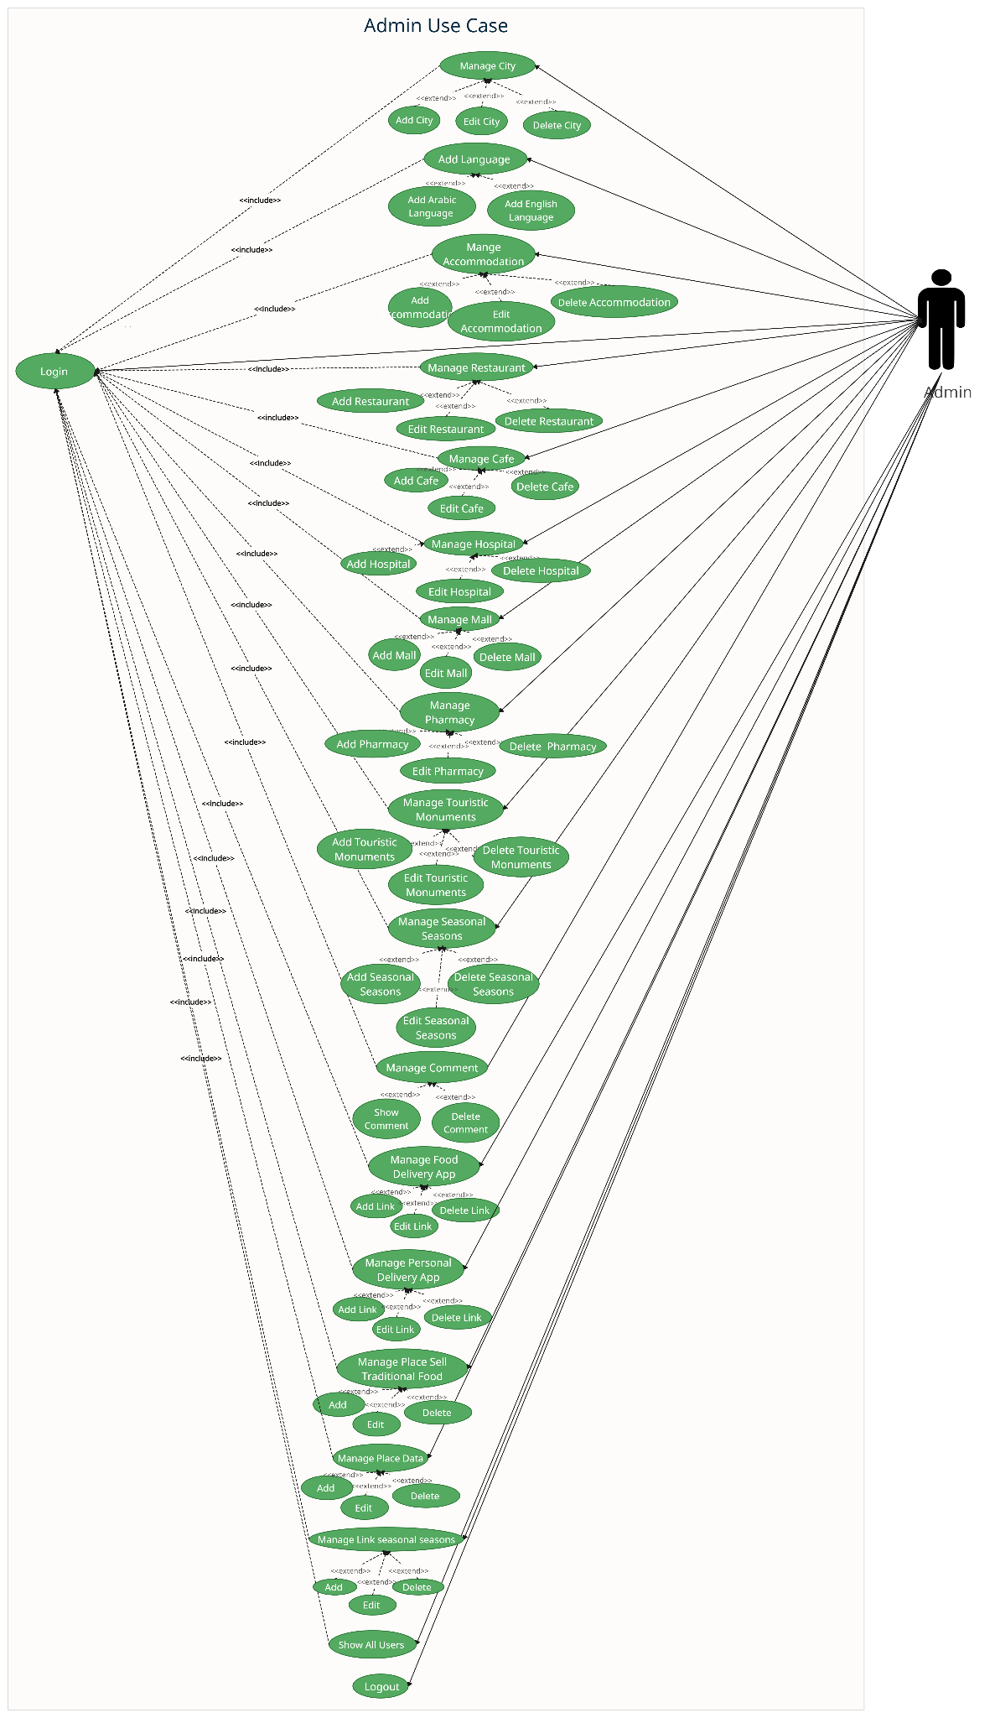

Figure 14 (System Use Case Diagram Admin)

**Second System Use Case Diagram for Tourist** [14]**.**

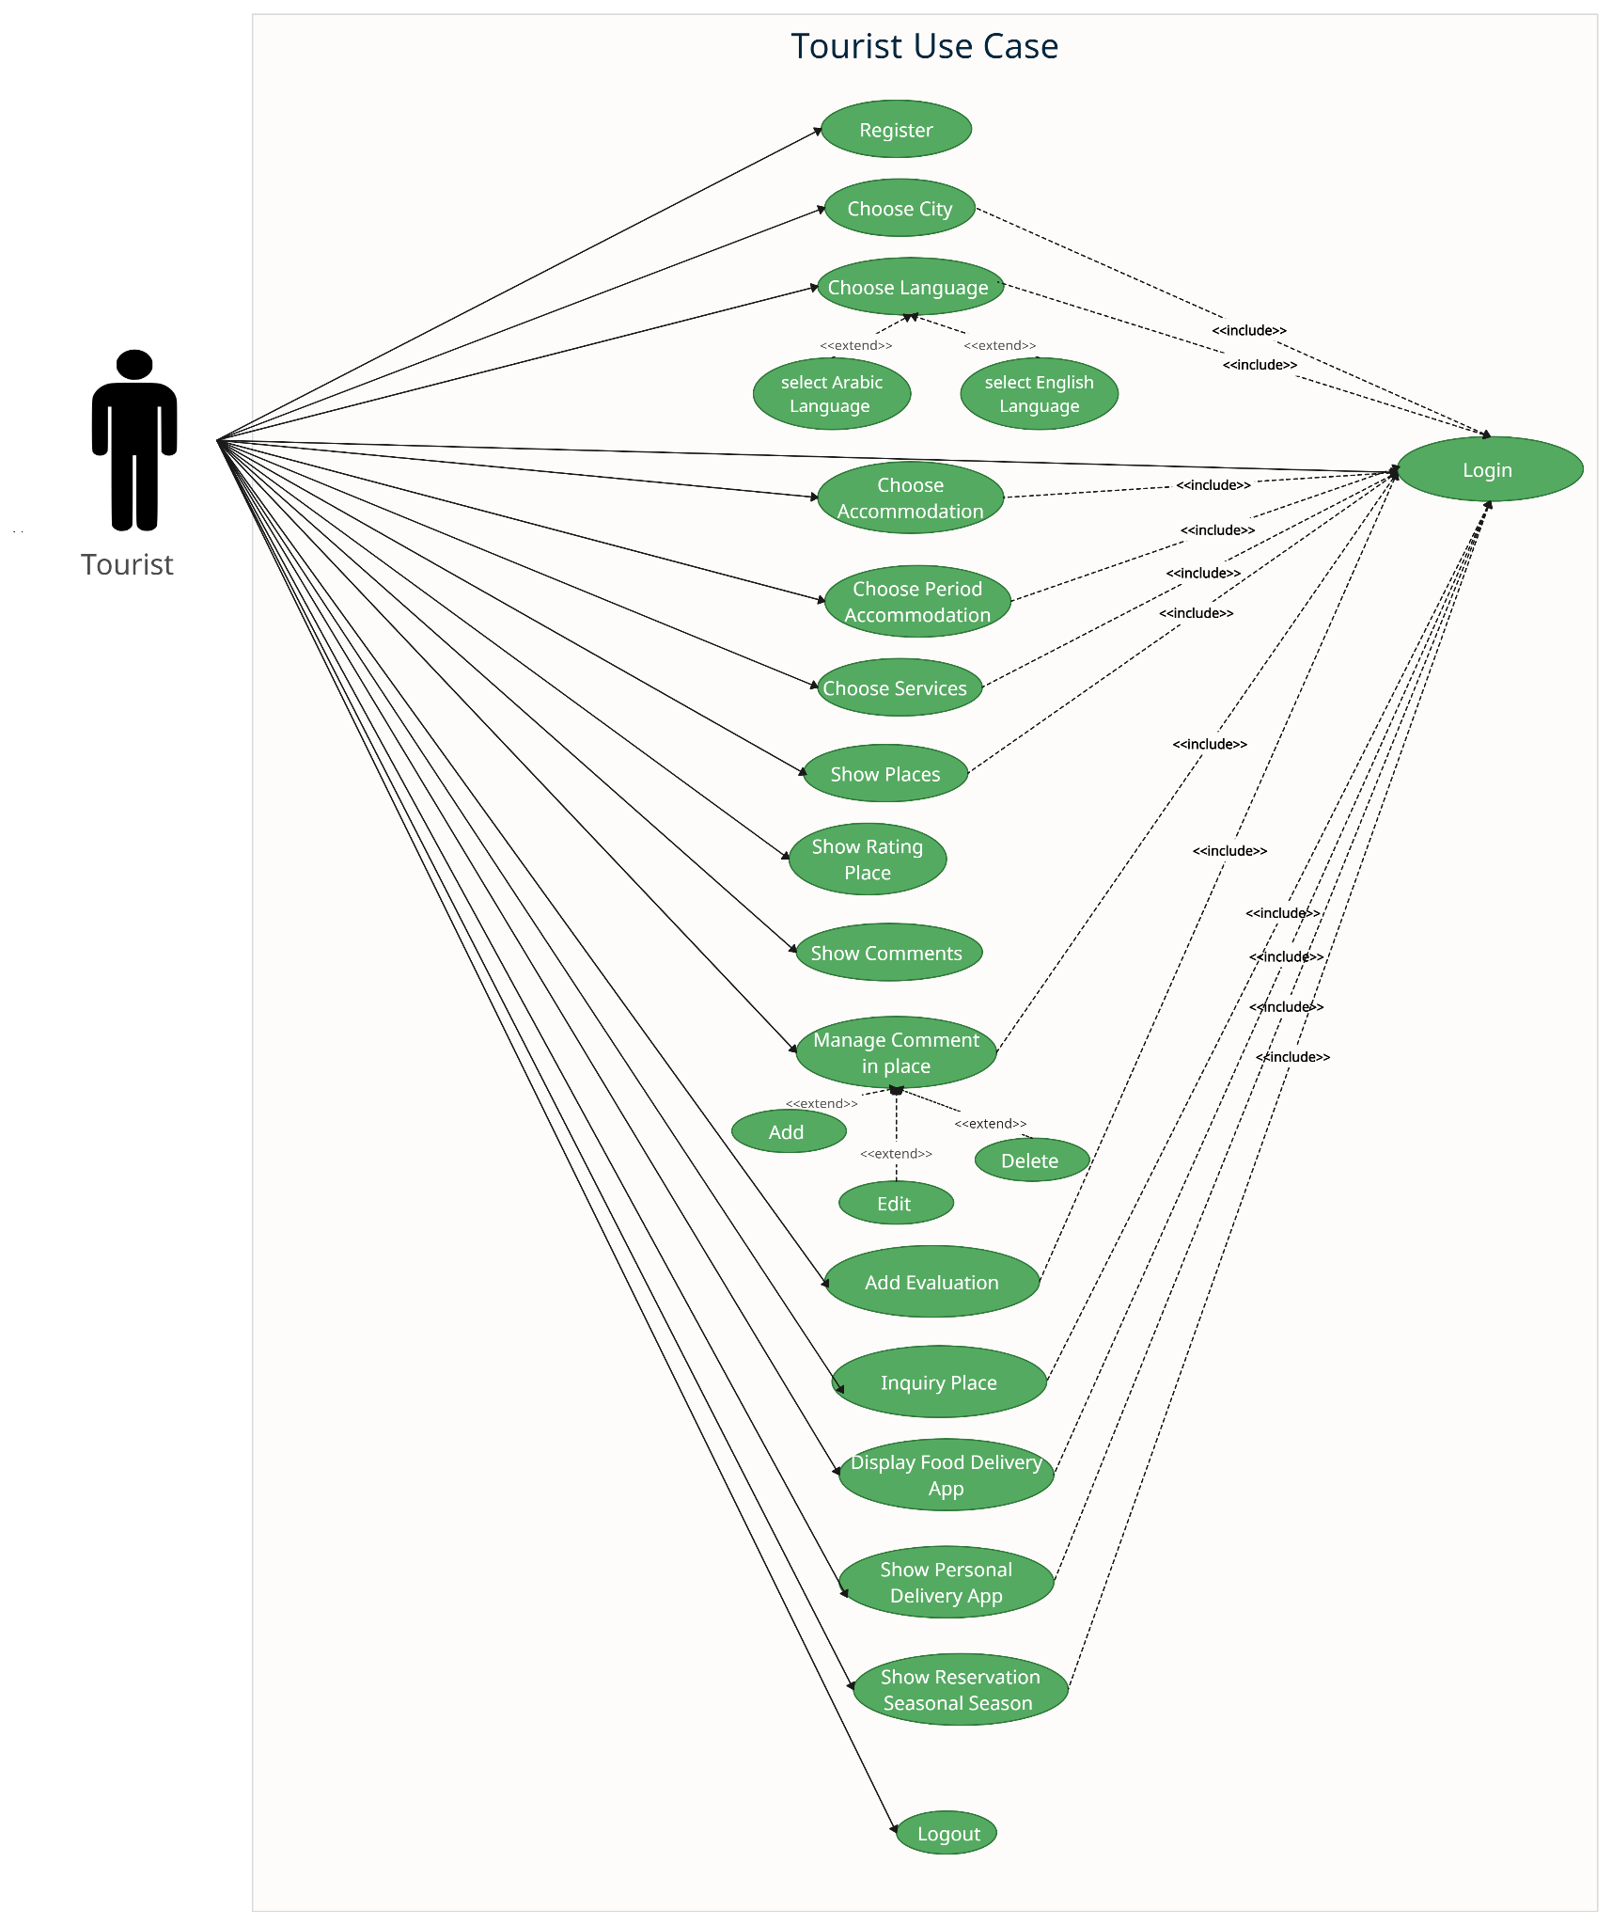

Figure 15 (System Use Case Diagram Tourist)

**Third System Use Case Diagram for Local Residents** [15]**.**

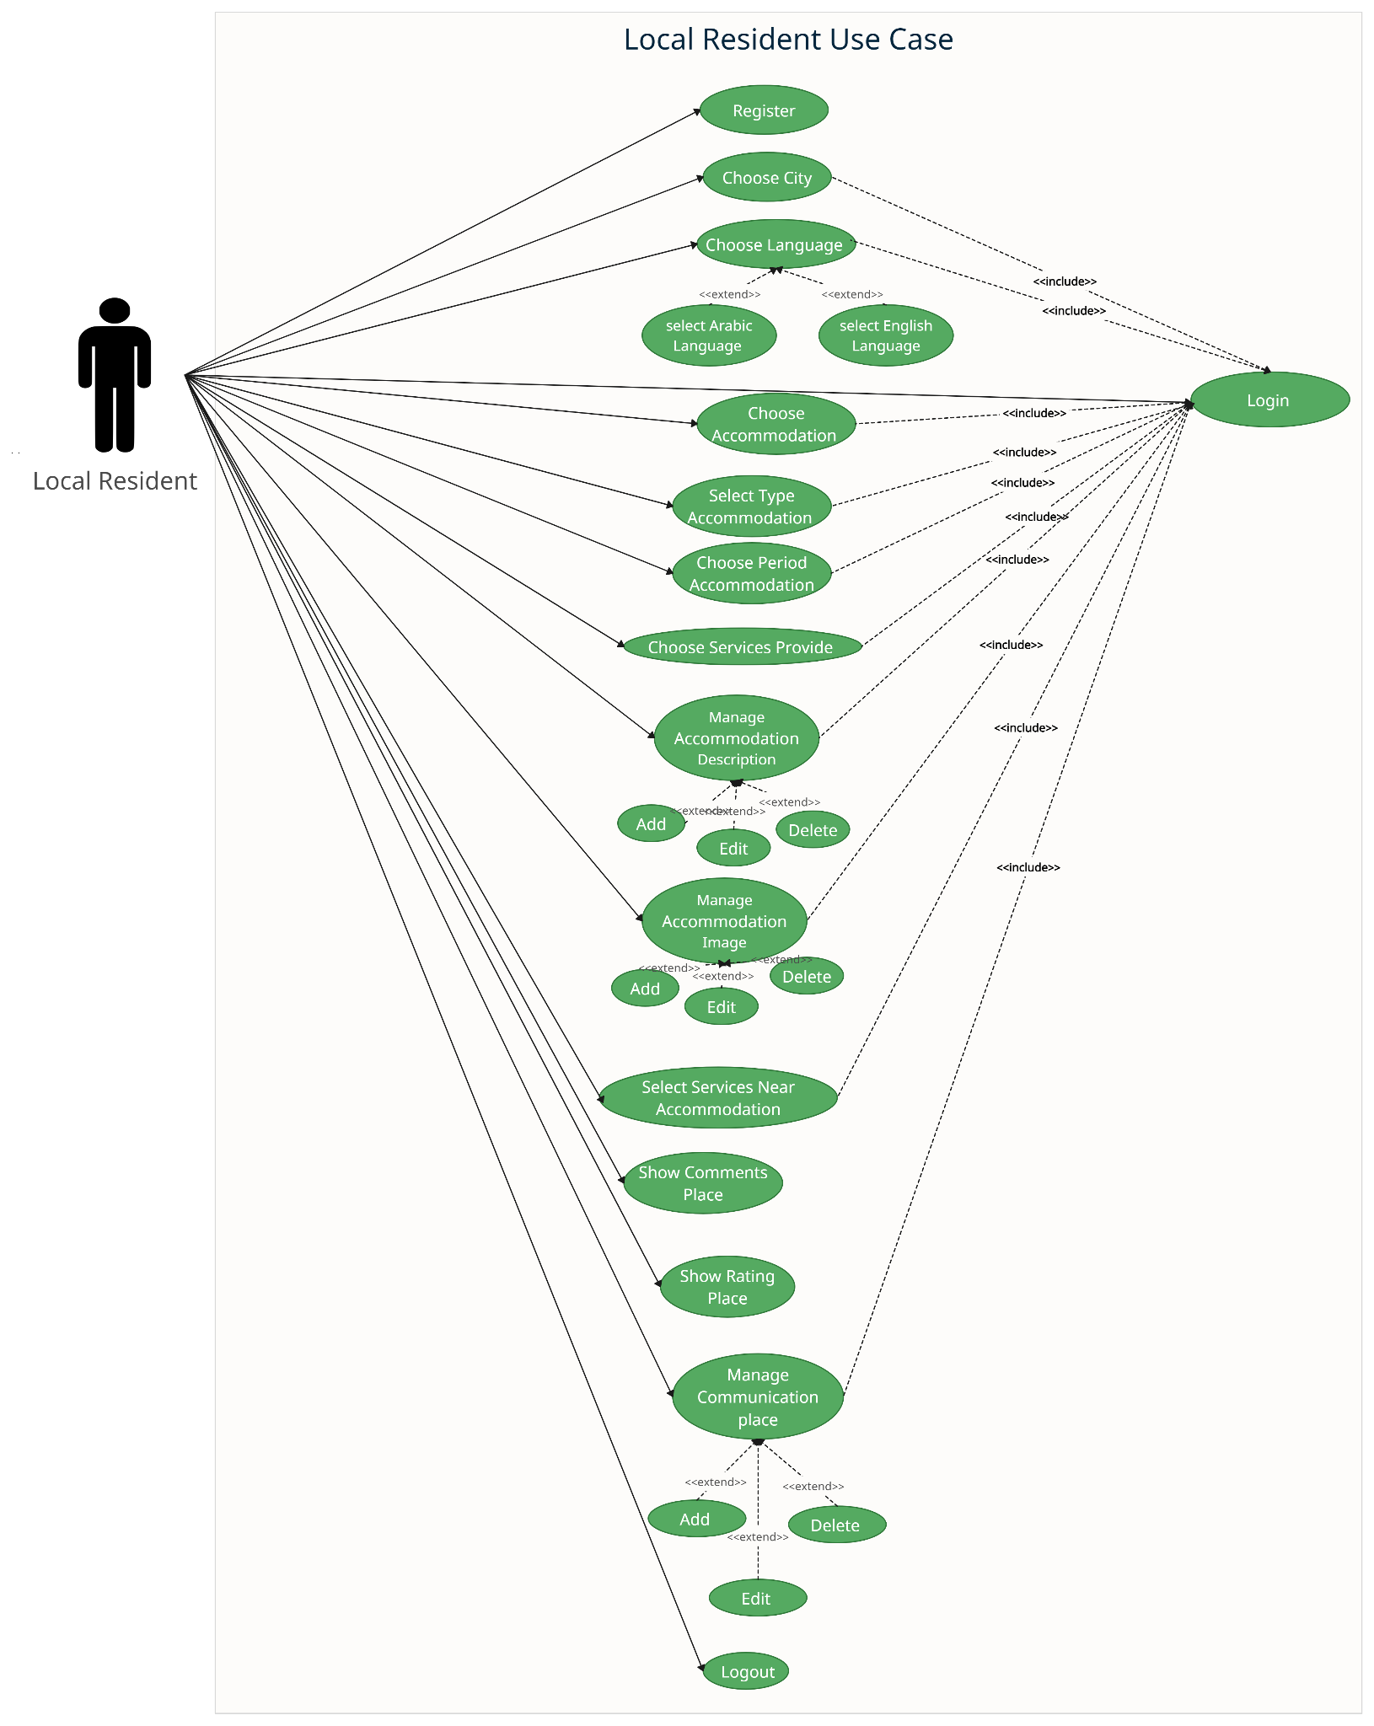

Figure 16 (System Use Case Diagram Local Resident)

**4.3 Class Diagram**

The class diagram depicts a static view of an application. It represents the types of objects residing in the system and the relationships between them. A class consists of its objects, and also it may inherit from other classes. A class diagram is used to visualize, describe, and document various different aspects of the system, and also construct executable software code.

It shows the attributes, classes, functions, and relationships to give an overview of the software system. It constitutes class names, attributes, and functions in a separate compartment that helps in software development. Since it is a collection of classes, interfaces, associations, collaborations, and constraints, it is termed a structural diagram. [16]

**The following figure presents the class diagram of the proposed system** [17]**.**

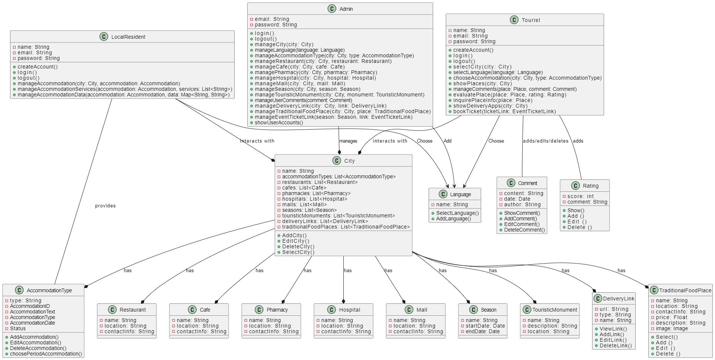

Figure 17 (Class Diagram)

**4.4 Conclusion**

In this chapter, we defined and designed the use case diagram that explains and organizes the system requirements.

We also defined and designed the class diagram that describes the system architecture.

**Chapter 5**

**Implementation**

# 

# **5.1 Introduction**

In this chapter, we will system architecture, database design, implementation requirement, user interfaces design.

**5.2TOOLS Selection: Database and programming**

**‏**Various tools in programming and databases are available, enabling

efficient system development based on project requirements and

performance criteria.

**5.2.1 Database**

There are various tools available for efficiently managing and storing data, such as MySQL, PostgreSQL, MongoDB, and Microsoft SQL Server. These tools are characterized by diverse features, including scalability, reliability, and flexibility, and all were available for use. However, we selected **Firebase** as it best meets the requirements of our project.

**5.2.2 Programming Language**

‏Several programming languages, such as Java, Python, C++, and JavaScript, were available for application development. For this project, we chose Flutter and Dart for their flexibility and efficient development process.

**5.3 FIREBASE REALTIME DATABASE**

Firebase Realtime Database is a cloud-based NoSQL database that stores

data.

in JSON format and syncs it in real time across devices. It allows offline

access.

and integrates easily with other Firebase services, ensuring strong security.

through Firebase Authentication.

**Why We Chose It:**

* Real-time synchronization.
* Offline access.
* Easy integration with Google services.

[18]

4.

**5.4 FLUTTER (DART)**

Flutter is an open-source toolkit by Google for building natively compiled apps using the Dart language.

**Why We Chose It:**

* Cross-platform development (iOS & Android).
* Fast development with “hot reload.”
* High performance and customizable UIs.

**5.5 DATABASAE**

We have created a database called "wajhatuk2030" it contains five tables:

•Users

• Cities

• Places

• ⁠Ratings

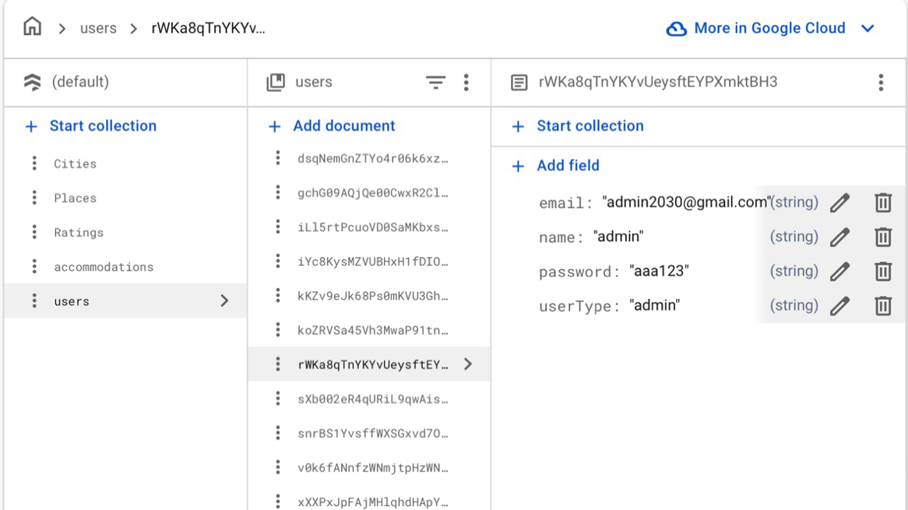•accommodations

Figure 18 ( Database )

**The Apps table contains some app information. It contains columns:**

**The Cities table contains some app information. It contains columns: ‏**

‎‏ • CitiesID (PK)

‎‏ • City_name

‎‏ • Created_at

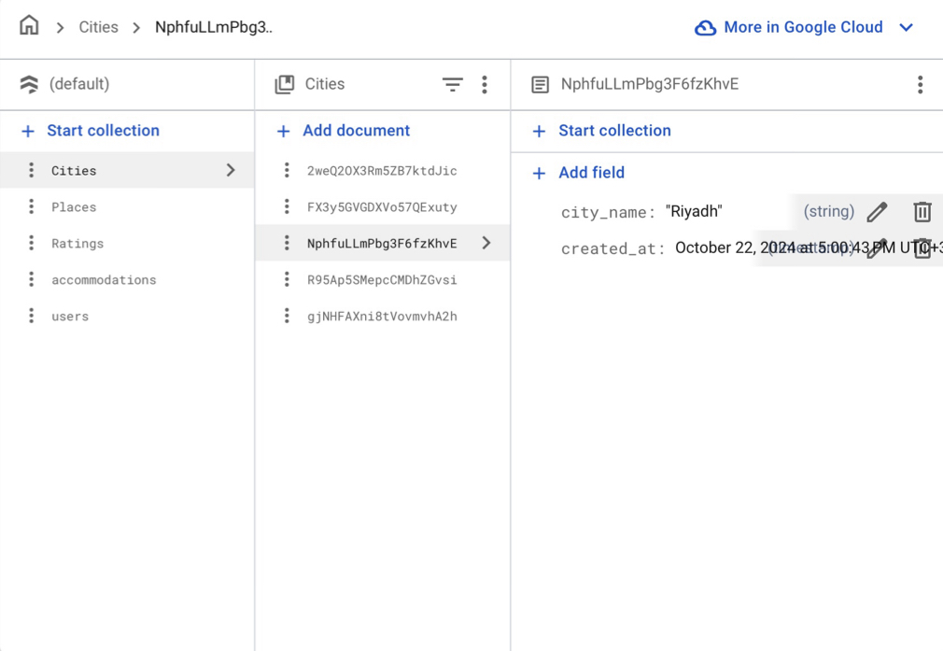Below are examples of Cities

Figure 19 ( Database )

**The Place table contains some app information. It contains columns:**

‎‏ • PlaceID (PK)

‎‏ • City_ID (FK)

‎‏ • User_ID (FK)

‎‏ • Created_at

‎‏ • image_url

‎‏ • Location_link

‎‏ • Place_details

‎‏ • Place_name

‎‏ • Place_type

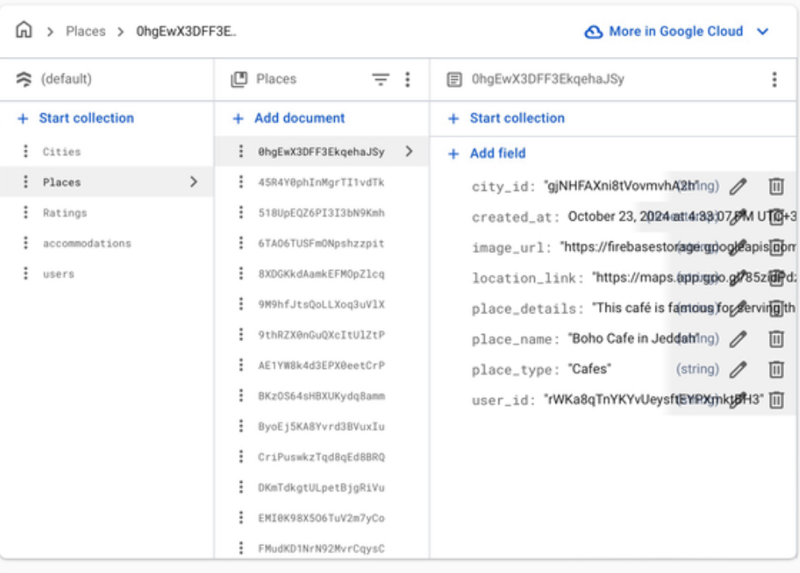Here is example of Plcce'Cafe '

Figure 20 ( Database )

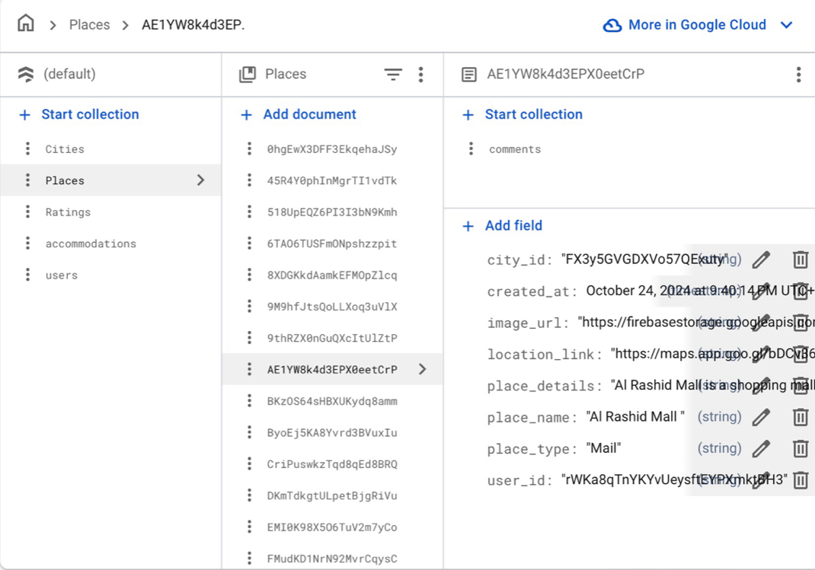 Here another example of Place 'mall'

Figure 21 ( Database )

**The Ratings table contains some app information. It contains columns:**

‎‏ • RatingsID (PK)

‎‏ • Place_ID (FK)

‎‏ • User_ID (FK)

‎‏ • Created_at

‎‏ • Rating

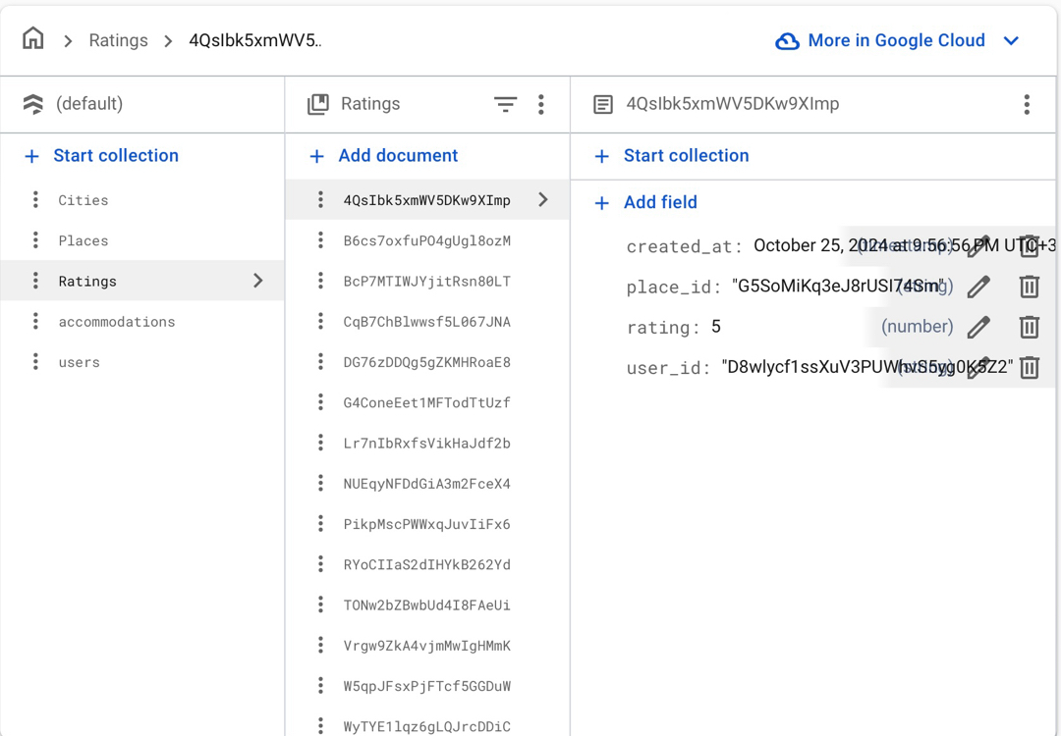Below are an example of Ratings

Figure 22 ( Database )

**The Accommodations table contains some app information. It contains columns:**

‎‏ • Accommodations_ID (PK)

‎‏ • City_ID (FK)

‎‏ • User_ID (FK)

‎‏ • AccommodationDate

‎‏ • AccommodationDetails

‎‏ • AccommodationText

‎‏ • AccommodationType

‎‏ • ImageUrl

‎‏ • LocationLink

‎‏ • Phone

‎‏ • Price

‎‏ • PriceUnit

‎‏ • Status

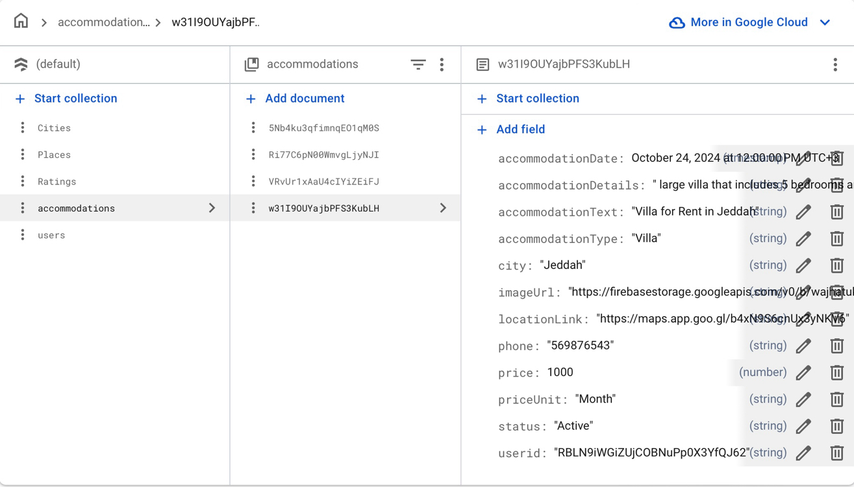Below are examples of Accommodations

Figure 23 ( Database )

**The User table contains some app information. It contains columns: ‏**

‎‏ • UserID (PK)

‎‏ • email

‎‏ • name

‎‏ • UserType

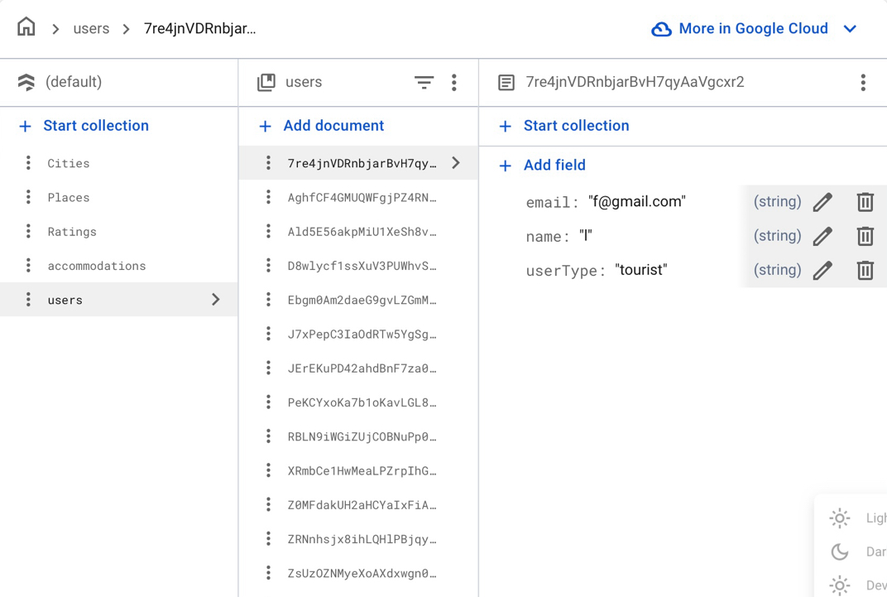Here is example of User 'tourist'

Figure 24 ( Database )

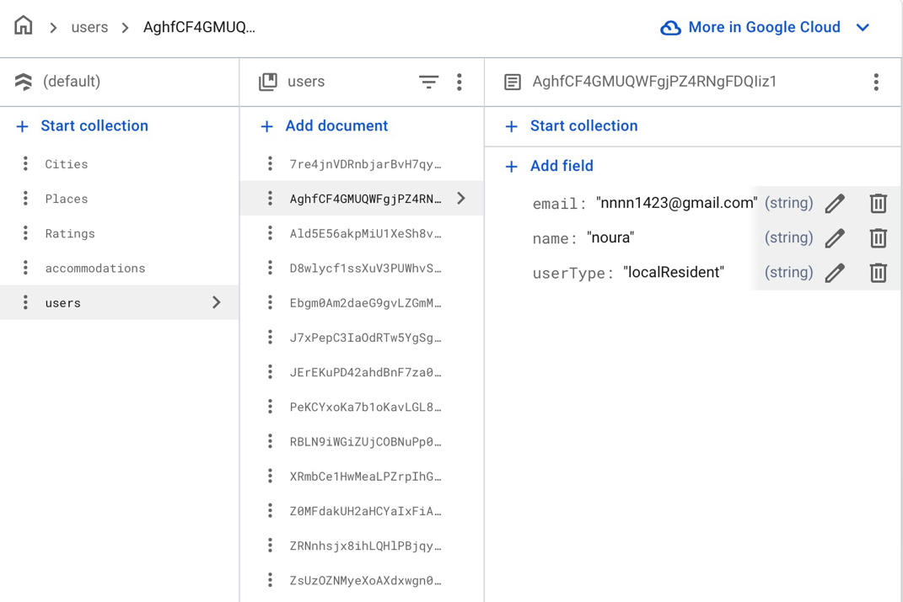And here another example of User

Figure 25 ( Database )

**5.6 User Interface Design**

**5.6.1 Shared Interface**

In the beginning, the pages shared between users (Local Resident – Tourist - Admin) will be displayed.

- Create an account page.

- Login page.

- Profile page.

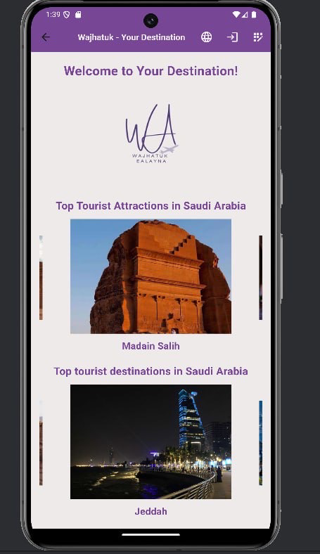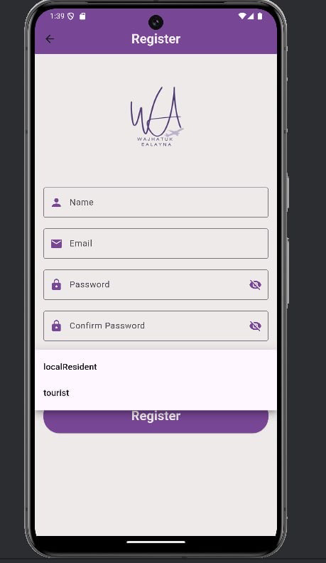

Figure 26 ( Main page ) Figure 27 ( Create account )

**Login page** includes fields for Email and Password, with the option to hide the password by clicking the eye icon. Below the fields, there is a "Forgot Password" option. Additionally, there are two purple buttons: "Login" to access your account after entering all your details, and "Register" to create a new account.

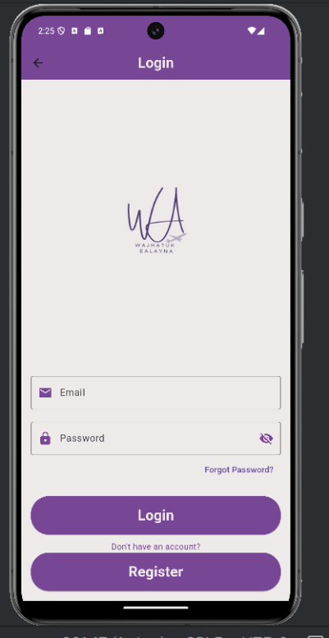

Figure 28 ( Login )

The Profile Page for both the Admin and Local Resident is the same, but the Tourist profile differs slightly because it has a bottom navigation bar.

However, the Profile Page for all of them contains account information and an Update button. From here, you can change your password, name, and other details.

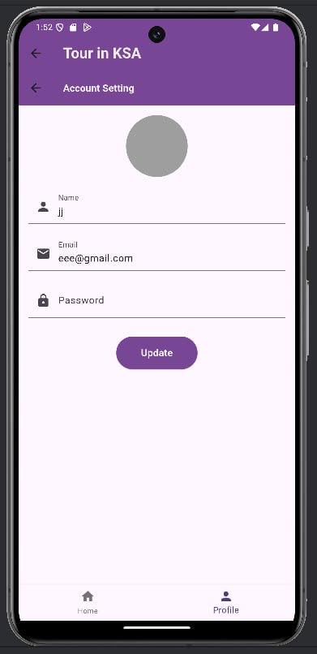

Figure 29 ( Profile page )

**5.6.2 Admin Interface**

This is the admin login page, and this is the admin dashboard, which contains four buttons.

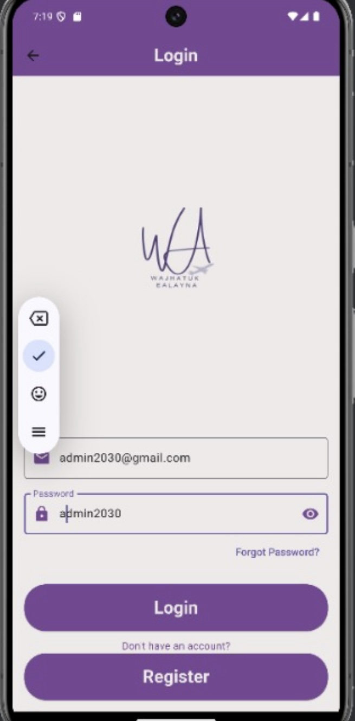

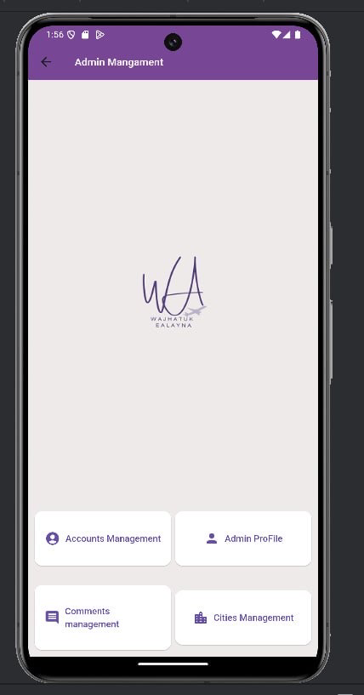

Figure 30 ( Home page ) Figure 31 ( Login )

The fourth tab (cities Management) to view, add, modify, and delete cities. When you click on add button, this interface appears to add city and also here is the same process when clicking on the delete and edit buttons.

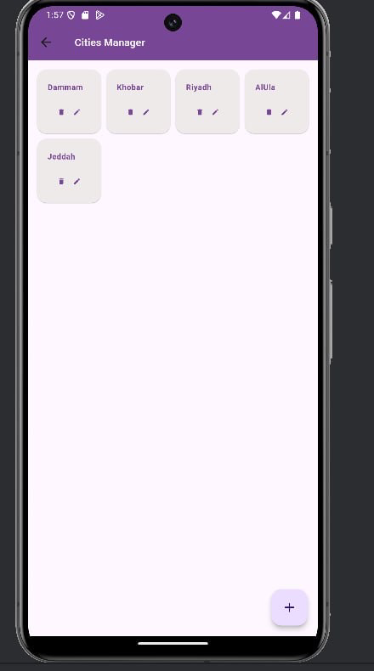

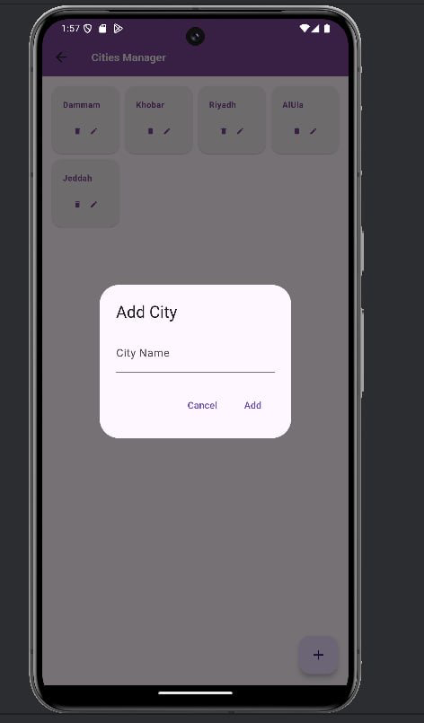

Figure 32 ( Cities Management) Figure 33 ( Cities Management)

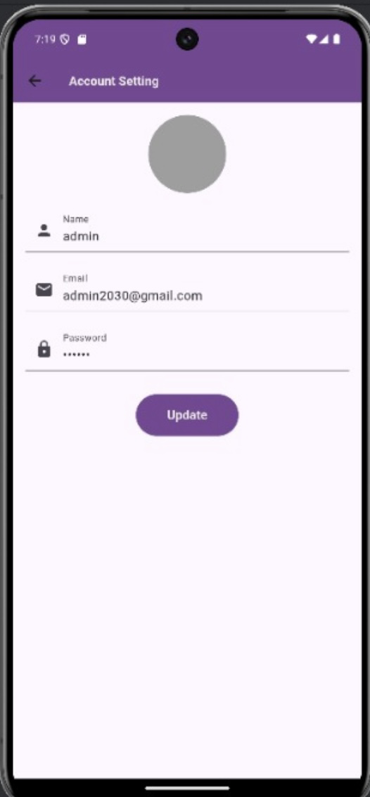The second tab (Admin Profile) When you click the second button, Admin Profile, it resembles the Tourist Profile and Local Resident Profile pages.

Figure 34 ( Admin Profile )

The first tab (Account Management) to view, delete user. When you click on delete button, this interface appears to delete, when click on yes the user will be removed from the list and its state in the database will change to (disabled). The third button (Comment Management), displays user comments and star ratings, giving you the option to edit or delete them.

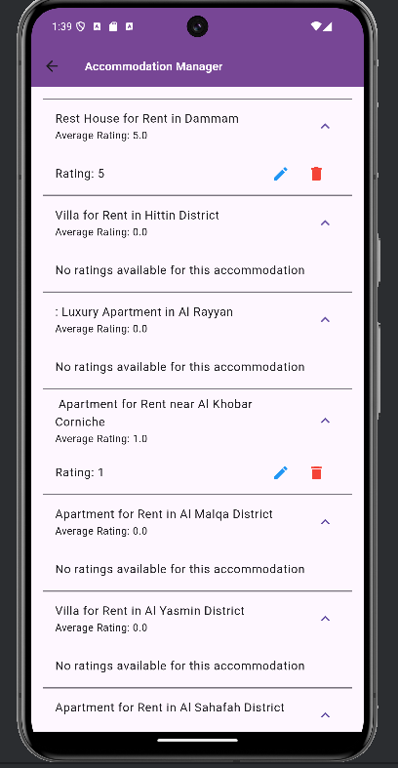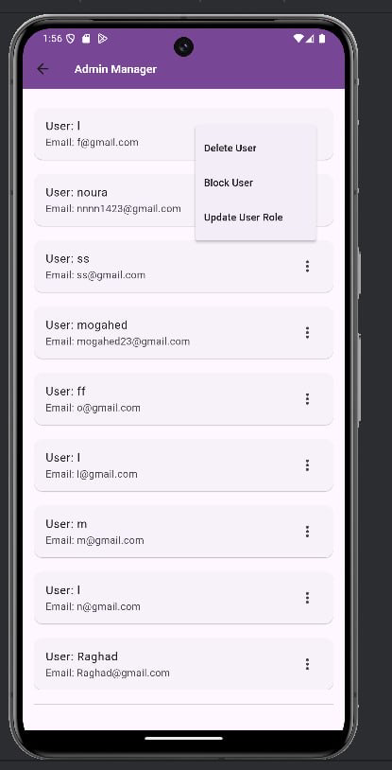

Figure 35 ( Comment Management ) Figure 36 ( Account Management)

**5.6.3 Tourist Interface**

The Register page is similar to the Login page, but the difference for a Tourist is that they have a bottom navigation bar with two icons: a home icon and a profile icon.

When clicking the Home button, it opens a page with a top scrollable bar showing cities, and the main page displays tiles for available services or places.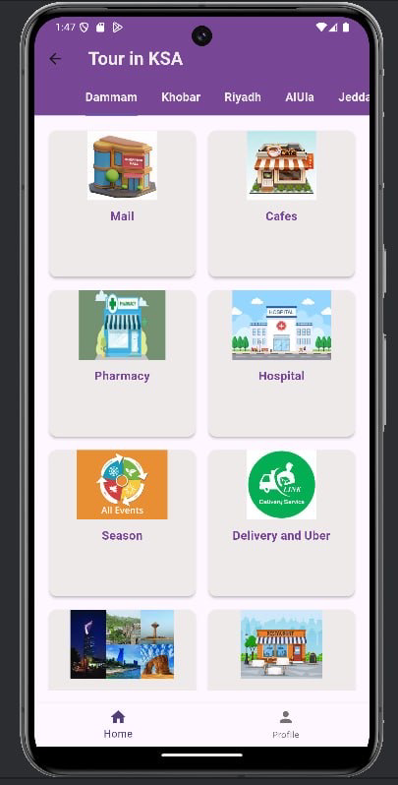



Figure 37 ( Home page ) Figure 38 ( Login )

Here are some examples of services in the city of Al Khobar

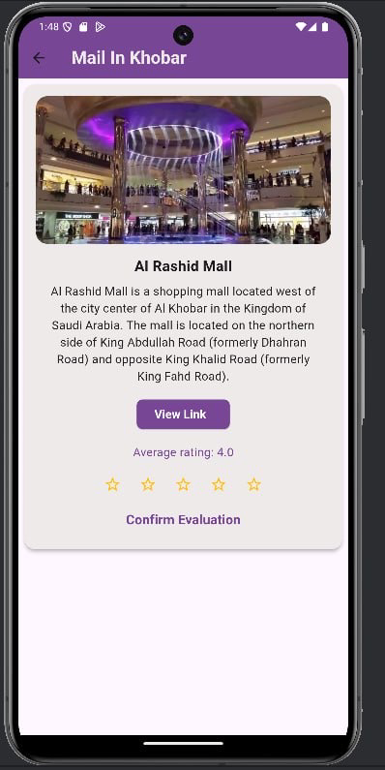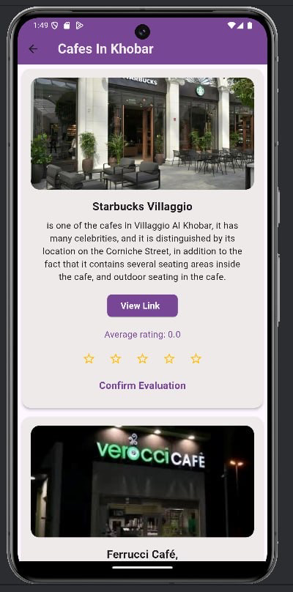

Figure 39 ( Cafes page ) Figure 40 ( Mall page )

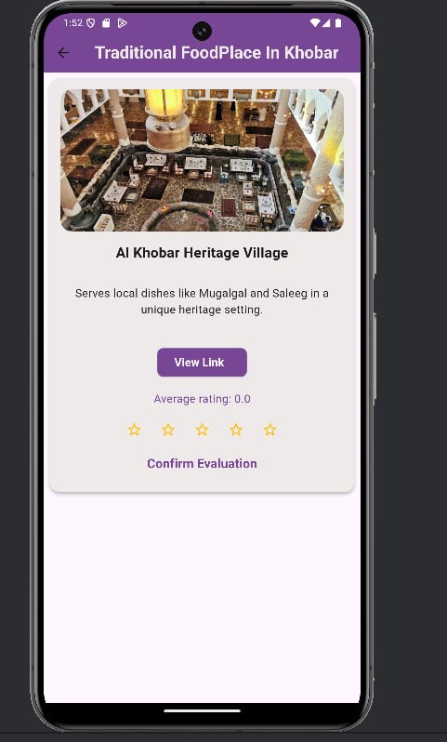

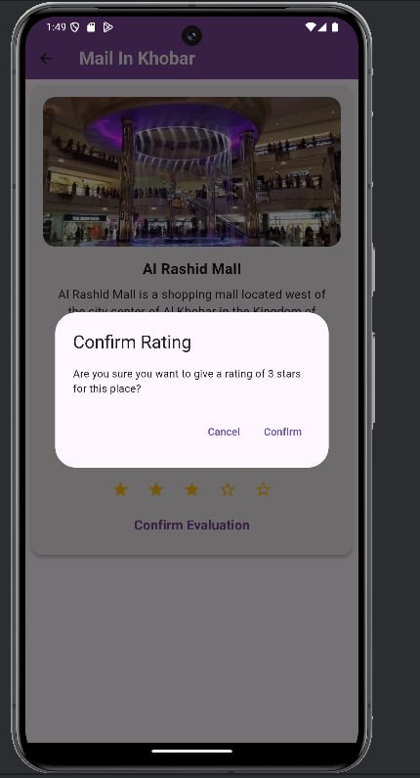From the Stars option, you can rate the place by selecting how many stars you want to give.

Figure 41 ( Stars option) Figure 42 ( Stars option)

After that, an option will appear labeled "Enter Comment Here" for you to write your feedback.

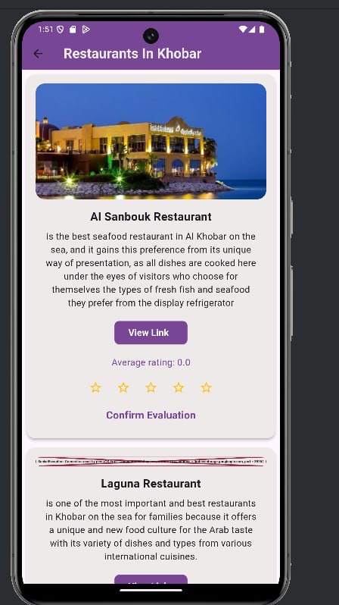

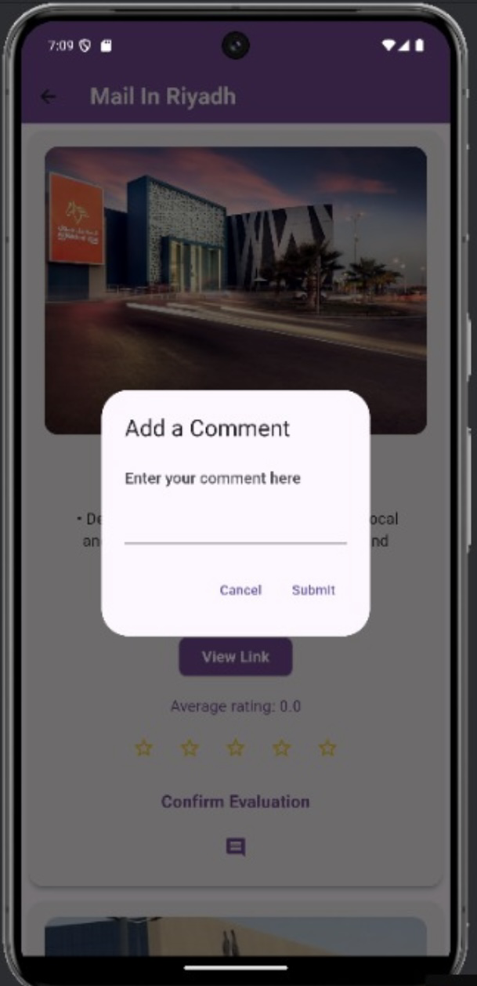

Figure 43 ( Comment ) Figure 44 ( Comment )

Here are some examples of services in the city of Al Khobar

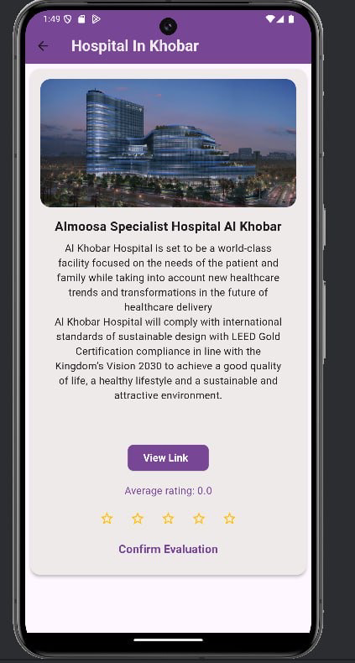

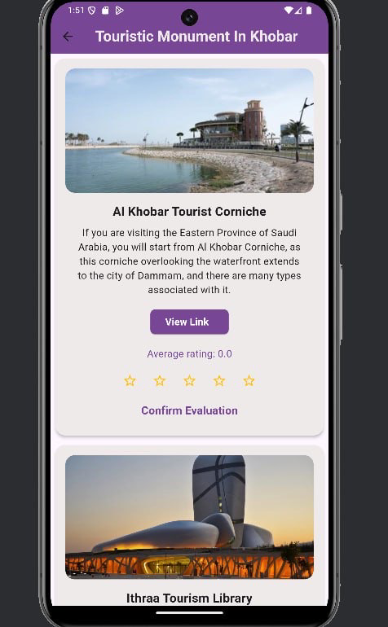

Figure 44 ( Touristic monument )Figure 44 ( Hospital page )

When you click on the Delivery and Uber tile, a list of recommended and verified apps will appear, such as Mrsool and HungerStation.

However, when you click the Profile icon in the bottom navigation bar, it will take you to a Profile Page similar to the other profile pages.

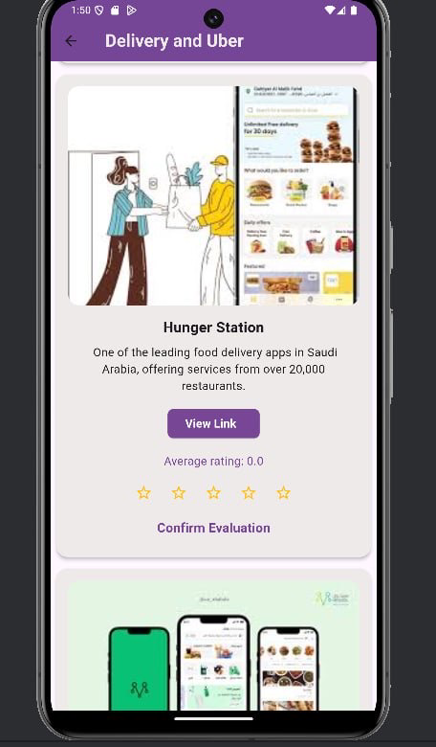

Figure 45 ( Delivery and Uber)Figure 46 ( profile pages)

**5.6.4 Local Resident Interface**

When logging in as a Local Resident, a welcome message will appear. After clicking Start, you'll see four buttons:

- Profile Management

- Comment Management

- Accommodation Management

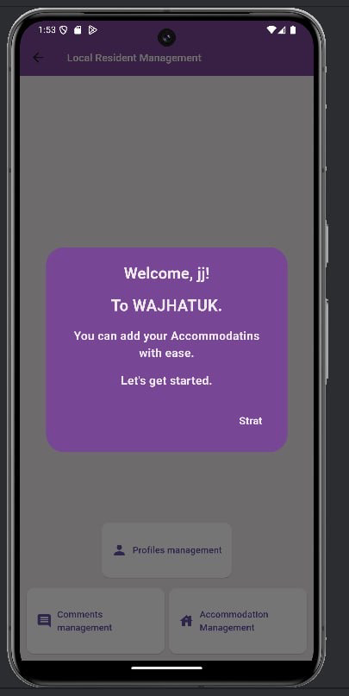

Figure 47 ( Home pages)

When you click on the Accommodation Management button, a page will appear showing the properties you've added. If you haven't added any properties yet, the page will be empty.

In the bottom corner, there's a plus icon. When clicked, it allows you to add a new property. From here, the user can enter all the required details and upload images of the property.

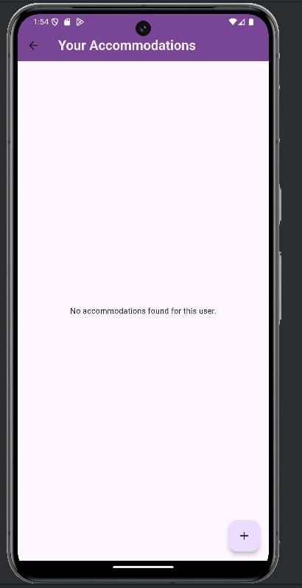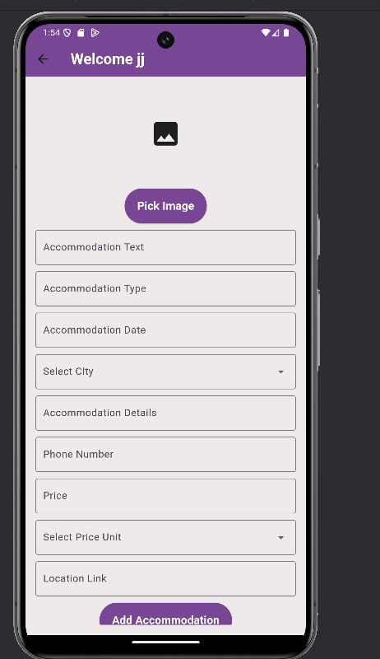

Figure 48 ( Accommodation Management)Figure 49 ( Accommodation Management)

Once you add a property, it will appear on this page.

The second page is accessed by clicking Comment Management in your properties. This page allows you to manage the comments and ratings for your properties.

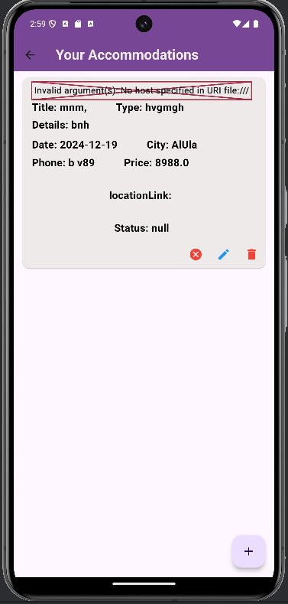

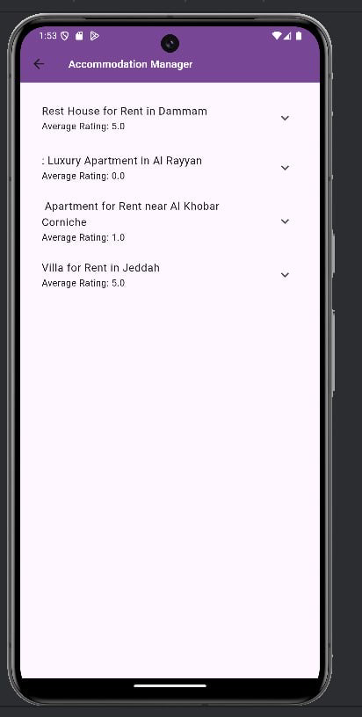

Figure 50 ( Comment Management)Figure 51 ( Accommodation Management)

# **5.7 Conclusion**

**Chapter 6**

**Summary & Conclusion**

**6****.1 Summary & Conclusion**

“Wajhatuk Ealayna” tour guide is considered a companion for every tourist who wants to explore the beauty of the Kingdom of Saudi Arabia. The guide provides comprehensive and reliable information about amazing tourist places and enjoyable tourist experiences throughout the Kingdom, making it easier for tourists to plan their trips easily and smoothly.

Not only that, “Wajhatuk Ealayna” also works to support local residents by enabling them to enhance their income by renting their properties by the day or for the preferred period to tourists, which gives them the opportunity to benefit from their properties in a positive and meaningful way, without hardship.

This is not limited to that, but the guide provides direct links to booking taxis, food orders, and other basic tourist services, ensuring tourists a comfortable and enjoyable travel experience without any hassle.

In short, “Wajhatuk Ealayna” is the ideal companion for both locals and tourists, combining comfort, diversity, and a unique experience in exploring the beauty of the Kingdom of Saudi Arabia.

The project began with an introduction highlighting the importance of technology. We then described the problem that led to the selection of the project, after which we presented the proposed system in greater detail, followed by defining the project objectives and scope and explaining the methodology used using the waterfall model to facilitate understanding and follow-up of the tasks. Finally, we developed a plan to implement the project.

Then, we started a new chapter where we included the work related to our project. We selected six applications, discussed the content of each application as well as its advantages and disadvantages, and compared them to analyze the differences between them. In the next chapter, we discussed the users who interact with the system and their functional and non-functional requirements. In the last chapter, we created a user case diagram and a class diagram that will help in understanding the parts of the project precisely. Finally, in the next chapter, we will implement the project by converting it into an application.

**References**

[1] “Waterfall Model,” [Online]. Available:

<https://www.lucidchart.com/blog/waterfall-project-management-methodology>. [Accessed 20 01 2024].

[2] “wekebidea,” [Online]. Available:

<https://en.wikipedia.org/wiki/Google_Sheets>. [Accessed 25 01 2024].

[3] “Google Sheet,” [Online]. Available:

<https://docs.google.com/spreadsheets/d/1f-Fqv02sD0CwqnnkiAeCP9M08eq9Nf06Q9TSJMWlSbM/edit#gid=1709744959>. [Accessed 25 01 2024].

[4] “ Program Ruh Al-Saudi,” [Online]. Available:

<https://apps.apple.com/sa/app/visit-saudi-%D8%B1%D9%88%D8%AD-%D8%A7%D9%84%D8%B3%D8%B9%D9%88%D8%AF%D9%8A%D8%A9/id818179871>. [Accessed 01 02 2024].

[5] “Saudi Events,” [Online]. Available:

<https://apps.apple.com/sa/app/saudi-events-%D9%81%D8%B9%D8%A7%D9%84%D9%8A%D8%A7%D8%AA-%D8%A7%D9%84%D8%B3%D8%B9%D9%88%D8%AF%D9%8A%D8%A9/id1481514428?l=ar>. [Accessed 02 02 2024].

[6] “Gathern,” [Online]. Available:

<https://apps.apple.com/us/app/gathern-%D8%AC%D8%A7%D8%B0%D8%B1-%D8%A5%D9%86/id1226060828>. [Accessed 03 02 2024].

[7] “Saudi Tourism Tour,” [Online]. Available:

<https://apps.apple.com/us/app/%D8%AC%D9%88%D9%84%D8%A9-%D8%A7%D9%84%D8%B3%D9%8A%D8%A7%D8%AD%D8%A9-%D8%A7%D9%84%D8%B3%D8%B9%D9%88%D8%AF%D9%8A%D8%A9/id1536948810>. [Accessed 04 02 2024].

[8] ”Tripadvisor,” [Online]. Available: <https://www.tripadvisor.com/>. [Accessed 05 02 2024].

[9] “Halabak,” [Online]. Available:

<https://apps.apple.com/sa/app/%D9%87%D9%84%D8%A7%D8%A8%D9%83/id1621288723?l=ar>. [Accessed 06 02 2024].

[10] “Functional Requirement,” [Online]. Available: <https://www.altexsoft.com/blog/functional-and-non-functional-requirements-specification-and-types/> [Accessed 24 02 2024].

[11] “Non-Functional Requirement,” [Online]. Available: <https://scaledagileframework.com/nonfunctional-requirements/> [Accessed 24 02 2024].

[12] “Defining Use Case,” [Online]. Available:

<https://www.ibm.com/docs/en/product-master/12.0.0?topic=processes-defining-use-cases>. [Accessed 26 03 2024].

[13] “System Use Case Admin,” [Online]. Available:

<https://app.creately.com/d/POJeWWcsm7a/edit>. [Accessed 26 03 2024].

[14] “System Use Case Tourist,” [Online]. Available:

<https://app.creately.com/d/POJeWWcsm7a/edit>. [Accessed 26 03 2024].

[15] “System Use Case Local Resident,” [Online]. Available:

<https://www.ibm.com/docs/en/product-master/12.0.0?topic=processes-defining-use-cases>. [Accessed 26 03 2024].

[16] “UML Class Diagram - Javatpoint,” [Online]. Available:

<https://www.javatpoint.com/uml-class-diagram>.[Accessed 27 03 2024].

[17] “Class Diagram,” [Online]. Available:

<https://app.creately.com/d/POJeWWcsm7a/edit>. [Accessed 27 03 2024].

[18] “Firebase Realtime Database”:

[https://www.sfahat.com/article/36/ما-هو-فايربيز-firebase-وما-الغاية-منه](https://www.sfahat.com/article/36/%D9%85%D8%A7-%D9%87%D9%88-%D9%81%D8%A7%D9%8A%D8%B1%D8%A8%D9%8A%D8%B2-firebase-%D9%88%D9%85%D8%A7-%D8%A7%D9%84%D8%BA%D8%A7%D9%8A%D8%A9-%D9%85%D9%86%D9%87)